Identifying feature drift using variable importance and MCR
by
Shreyash Chetan Meshram
Student ID: 20811152
Supervisor: Professor Gavin Smith
Programme: MSc Business Analytics
University of Nottingham
2026
A Dissertation presented in part consideration for the degree of MSc Business Analytics
Submission date: 3 September 2026
Word count: 13,910 (abstract and main text; excludes title page, acknowledgements, declaration, contents, lists, tables, captions, references and appendices)

Abstract
Models deployed on data streams degrade when the relationship between features and outcome changes. Degradation is usually detected by monitoring predictive error, which reports harm only once it has accumulated. Variable-importance monitoring has been proposed as an earlier indicator, on the grounds that the features a model relies upon should move before its accuracy does. This dissertation examines when that expectation holds.
Two experiments were conducted. A rotating-hyperplane benchmark of 200,000 instances supplies real concept drift: P(X) is stationary while P(y | X) moves. Three signals were evaluated there: SHAP importance departure under per-window refitting, the same departure on the frozen deployed model, and ensemble vote dominance. Each was calibrated against a bootstrap null band, converted to alarms by a three-window persistence rule, tested under a permutation negative control, and compared with DDM and ADWIN. Separately, a Boolean validation harness with exact ground truth was used to enumerate all ten two-feature subsets at every timestep and record which suffice to determine the label.
On the benchmark the refitted signal alarmed at window 1 and the deployed model degraded measurably at window 8, an observed lead of seven windows; DDM also alarmed at window 1 and ADWIN at window 14. Frozen attribution and vote dominance produced no sustained alarm. That silence is predicted rather than a failure: a label-free statistic of a frozen model reads P(X) alone, and cannot systematically reveal movement in P(y | X) while P(X) is stationary. On the harness the set of sufficient feature pairs contracted from six to three and one feature became strictly necessary, while a perfect refitted predictor remained available throughout.
Whether drift is observable through variable importance therefore depends on what the statistic is computed from, not on the statistic itself. Exposing conditional drift required refitting, which requires labels, so the approach is not label-free. All timings are single-run point estimates on one stream realisation, and the degradation point is sensitive at approximately one-window resolution.

Acknowledgements
I would like to express my sincere gratitude to my supervisor, Professor Gavin Smith, for his guidance, constructive feedback and support throughout this dissertation. I am also grateful to the University of Nottingham Business School and the MSc Business Analytics programme for providing the academic environment and resources that supported this work.
I would like to thank my family and friends for their encouragement and patience throughout my studies. Their support has been invaluable during the research, implementation and writing of this dissertation.
Finally, I am grateful to everyone who contributed, directly or indirectly, to the completion of this work.

Declaration of LLM Assistance
I confirm that I used Large Language Model (LLM) assistance during the preparation of this dissertation. Its use was limited to supporting the research, coding and writing process, within the scope permitted by the University's guidance.
What LLM assistance was used for
- Debugging and reviewing Python code, including implementation errors and the use of scikit-learn, SHAP, River, NumPy and pandas.
- Checking function behaviour and parameters during notebook development.
- Improving the clarity and presentation of figures, tables and captions.
- Polishing academic English and maintaining consistent terminology.
- Helping organise and restructure dissertation sections.
- Assisting with citation and reference consistency checks, and identifying items requiring verification.
- Reviewing the final dissertation and notebooks for inconsistencies between reported results and executed code.
What LLM assistance was not used for
- Generating or fabricating numerical results. Every numerical result reported in this dissertation is taken from execution of the accompanying notebooks.
- Replacing execution of the analytical experiments.
- Making final methodological decisions. It was used for discussion, critique and checking, but the final decisions remained my own.
- Replacing my own interpretation of the results or the conclusions drawn.
- Submitting or assessing this dissertation.
Tools used
ChatGPT (OpenAI) and Claude (Anthropic) were used as LLM assistants during different stages of the project, primarily for the purposes described above.
Statement of authorship
The final methodological decisions, experimental results, interpretation and conclusions presented in this dissertation are my responsibility. Where LLM suggestions were incorporated into code, wording or presentation, I reviewed and revised them and checked substantive claims against the executed notebooks and relevant sources. I accept full responsibility for the content of this submission.

Table of Contents
Abstract 2
Acknowledgements 3
Declaration of LLM Assistance 4
Chapter 1: Introduction 9
1.1 Background and motivation 9
1.2 Problem definition 9
1.3 The proposed approach 10
1.4 Research questions and objectives 11
1.5 Scope and data 12
1.6 Dissertation structure 12
Chapter 2: Literature Review 13
2.1 Overview 13
2.2 Concept drift: definitions and taxonomy 13
2.3 Drift detection methods 14
2.3.1 Error-based detection 14
2.3.2 Distribution-based and model-internal detection 15
2.4 Variable importance and model explanation 15
2.5 Importance-based drift detection: an emerging intersection 16
2.6 Rashomon sets and reliance structure 17
2.7 Benchmark data and evaluation methodology 18
2.8 Synthesis and research gap 19
Chapter 3: Methodology 20
3.1 Overview and research design 20
3.2 The measurement problem 20
3.2.1 Frozen-model attribution under a stationary input distribution 20
3.2.2 Retraining as an instrument of measurement 22
3.3 Data and validation harness 23
3.3.1 Construction of the Boolean validation harness 23
3.3.2 Ground truth and the formal character of the harness 25
3.3.3 Rotating hyperplane primary stream 28
3.4 Experimental pipeline 29
3.4.1 Windowing and evaluation protocol 30
3.4.2 Base learner and configuration 30
3.5 Candidate drift signals 30
3.5.1 S1 Importance departure under refitting 31
3.5.2 S2 Frozen-model importance departure, as a control 31
3.5.3 S3 Ensemble vote dominance 31
3.5.4 S4 Exact sufficient-subset and reliance structure 32
3.6 Baseline detectors 33
3.7 From signal to detection: the null-band rule 33
3.7.1 Calibrating the null band 34
3.7.2 Matching the reference to the measurement 35
3.7.3 Permutation as a negative control 36
3.8 Evaluation metrics 37
3.9 Experimental programme 38
3.10 Reproducibility and computational environment 39
3.11 Ethical considerations 39
3.12 Limitations of the design 39
Chapter 4: Results and Analysis 42
4.1 Overview 42
4.2 Boolean validation-harness results 42
4.3 Rotating-hyperplane results 44
4.3.1 Behaviour of the candidate signals 44
4.3.2 Performance degradation and lead time 46
4.3.3 Error-based baselines and negative controls 49
4.4 Answers to the research questions 51
4.5 Chapter summary 52
Chapter 5: Discussion 53
5.1 Overview 53
5.2 RQ1: when do variable-importance signals detect drift? 53
5.3 RQ2: does importance movement provide useful lead time? 54
5.4 RQ3: comparison with the error-based baselines 55
5.4.1 Refitted SHAP and DDM 55
5.4.2 ADWIN 56
5.4.3 Vote dominance 56
5.4.4 Reliance structure 56
5.5 What the two arms establish together 57
5.6 Contributions 57
5.7 Implications for model monitoring practice 58
5.8 Limitations and what they restrict 59
5.9 Chapter summary 59
Chapter 6: Conclusions and Future Research 61
6.1 Conclusions against the research questions 61
6.2 Contributions 62
6.3 Implications for model monitoring 62
6.4 Limitations 63
6.5 Future research 63
6.6 Concluding remark 64
References 65
Appendix A Reproducibility and implementation configuration 70
A.1 Software environment 70
A.2 Base learner configuration 70
A.3 Windowing, attribution and calibration 70
A.4 Baseline detectors 71
A.5 Random seeds and permutation procedure 71
A.6 Execution and verification 71
Appendix B Boolean validation harness: construction and enumeration 72
B.1 Construction 72
B.2 Mutation schedule 72
B.3 Exhaustive enumeration of sufficient pairs and necessity 72
B.4 Verification of the dominance reference 73
List of Figures
Figure 2.1 Joint-distribution decomposition and drift types 13
Figure 2.2 Observability of monitoring signal sources 19
Figure 3.1 Measurement design and drift observability 21
Figure 3.2 Refitted versus frozen feature-importance movement 22
Figure 3.3 Feature D attribution on the Boolean harness 22
Figure 3.4 Boolean validation-harness construction 24
Figure 3.5 Evolution of Boolean reliance structure 26
Figure 3.6 Membership of sufficient feature pairs 27
Figure 3.7 Refitted and frozen harness accuracy 28
Figure 3.8 Refitted SHAP profiles on the hyperplane stream 29
Figure 3.9 Experimental monitoring pipeline 29
Figure 3.10 Frozen-ensemble disagreement on the Boolean harness 32
Figure 3.11 Bootstrap calibration of benchmark null bands 35
Figure 3.12 In-sample versus out-of-bag dominance calibration 36
Figure 3.13 Importance departures on the Boolean harness 37
Figure 4.1 First responses across the harness timesteps 43
Figure 4.2 Refitted and frozen SHAP departures 45
Figure 4.3 Frozen-model accuracy and detector alarms 46
Figure 4.4 Three-window degradation persistence 47
Figure 4.5 Benchmark alarm and lead-time comparison 48
Figure 4.6 DDM and ADWIN alarm locations 49
Figure 4.7 Chronological and negative-control timings 50
List of Tables
Table 3.1 Exact Boolean-harness reliance structure 25
Table 4.1 First responses on the Boolean harness 42
Table 4.2 Hyperplane null-band calibration 44
Table 4.3 Degradation-reference sensitivity 47
Table 4.4 Benchmark alarms and lead times 48
Table 4.5 Negative-control results 51

Chapter 1: Introduction

1.1 Background and motivation
Machine learning models are embedded in routine business decision-making, from credit scoring and demand forecasting to churn prediction and fraud detection. They are trained on historical data under the implicit assumption that past relationships continue to hold. That assumption fails routinely: consumer behaviour shifts, market conditions change, and external shocks alter the relationship between a model's inputs and its target. This phenomenon is known as concept drift (Gama et al., 2014), and when it occurs the deployed model becomes progressively wrong.
The standard operational response is to track predictive performance and retrain when it falls. This is inherently reactive: by the time accuracy has visibly degraded, the organisation has already acted on flawed predictions. Where ground-truth labels arrive with delay, as when a loan default is observed months after the lending decision, degradation may go unmeasured for an extended period. There is therefore clear value in drift signals that fire before performance visibly falls.

1.2 Problem definition
The problem can be stated precisely. A model is fitted at time t0 on data drawn from a joint distribution P0(X, Y) and thereafter deployed. Concept drift occurs when the distribution generating later instances differs from the one the model was fitted on:
Pₜ(X, Y) ≠ P₀(X, Y) for some t > t₀
The joint distribution factorises as P(X, Y) = P(X) · P(Y | X), and the two components have different consequences for a deployed model. A change in P(X) alone is virtual drift, or covariate shift: the model sees inputs from unfamiliar regions, but the boundary it learned remains correct. A change in P(Y | X) is real concept drift, and it is the damaging case, because the relationship the model encodes no longer holds (Gama et al., 2014; Webb et al., 2016). Section 2.2 develops this taxonomy and its temporal profiles.
These distinctions define the difficulty this dissertation attacks. The hardest case is real concept drift under a stationary input distribution: P(Y | X) moves while P(X) does not. The inputs then carry no signature of the change, so any method monitoring the input distribution is blind to it by construction. The only remaining evidence is the model's error rate, which cannot rise until the model is already making mistakes, and cannot be computed at all until labels arrive.
The problem is therefore to identify a signal satisfying three conditions at once: sensitivity to a change in P(Y | X) rather than in P(X); observability before the error rate has accumulated enough evidence to trigger a conventional detector; and, so far as possible, computability without waiting for labels. This dissertation asks whether signals derived from how a model distributes its reliance across features can meet them.

1.3 The proposed approach
This dissertation investigates whether early-warning signals can be extracted from how a model uses its variables rather than from how often it is wrong. The intuition is that when the input–output relationship changes, the pattern of feature reliance required to predict well changes with it, and that this internal reorganisation may be observable before its consequences accumulate in the error rate.
Three candidate mechanisms are investigated. The first tracks shifts in variable-importance profiles over time, computed with SHAP (Lundberg and Lee, 2017). The second monitors vote dominance within a random forest ensemble (Breiman, 2001a), asking whether the trees begin to disagree before their aggregate prediction changes; as Section 3.2.1 shows, this statistic is subject to the same structural limitation as frozen attribution. The third draws on the Rashomon set, the set of near-optimal models for a task, and on the reliance structure within it (Fisher, Rudin and Dominici, 2019; Dong and Rudin, 2020), asking whether the pattern of feature sufficiency shifts when drift occurs. All are evaluated against two established error-based detectors, DDM (Gama et al., 2004) and ADWIN (Bifet and Gavaldà, 2007).
One methodological point shapes the whole design. Explanation methods describe the model, not the environment: a frozen deployed model receiving inputs from a stationary distribution produces a stable importance profile however far the true relationship has moved beneath it. Preliminary experimentation confirmed and sharpened this. On a benchmark stream, importance recomputed on a refitted model shifted markedly while the same computation on the frozen model barely moved; on a purpose-built harness with exact ground truth, the frozen profile moved in the wrong direction entirely. Detecting real concept drift from importance signals therefore requires deliberate choices about which model is explained, and those choices are part of this dissertation's contribution.

1.4 Research questions and objectives
The dissertation addresses three research questions:
- RQ1. When real concept drift occurs, do variable-importance signals shift in a detectable way?
- RQ2. Do these signals shift earlier than predictive performance degrades; that is, do they provide useful early-warning lead time?
- RQ3. How do the SHAP-based, vote-dominance and reliance-structure mechanisms compare with error-based baselines in alarm timing, negative-control behaviour and lead time?
- The three questions are not answered on the same evidence, and the division is stated here because it governs every chapter that follows. RQ2, and the timing component of RQ3, are evaluated on the benchmark stream for signals S1 to S3. Signal S4, the exact reliance structure of Section 3.5.4, is evaluated separately as a proof of mechanism on the Boolean harness against exact ground truth; it is not computed on the benchmark stream, is not assigned a benchmark lead time, and is not entered into the benchmark permutation control or the timing comparison against DDM and ADWIN.
These questions are pursued through the following objectives:
- Review the concept-drift and explainability literatures to establish the research gap and select appropriate baselines and evaluation metrics.
- Implement a windowed pipeline computing importance-based, vote-dominance and reliance-structure signals alongside error-based baseline detectors, over a purpose-built validation harness with exact ground truth and a benchmark drift stream (Losing, Hammer and Wersing, 2016).
- Evaluate the detectors on alarm timing, on behaviour under a permutation negative control, and on lead time relative to measurable performance degradation, calibrating each continuous signal against a null band estimated from repeated refitting around an empirical reference window. Detection delay is reported on the Boolean harness, where drift onset is exactly dated; a false-alarm rate is not estimated on the benchmark stream, which contains no stable period from which one could be measured.
- Interpret the findings for model-monitoring practice, framing importance-based measurement as a diagnostic within a layered monitoring design.

1.5 Scope and data
The empirical work uses two sources. A purpose-built Boolean harness, in which the target function and the full reliance structure are known exactly at every timestep, validates the measurement code against ground truth. The rotating hyperplane stream from the benchmark collection of Losing, Hammer and Wersing (2016) supplies the primary experiment: its input distribution is stationary while the decision boundary rotates, so it isolates real concept drift from covariate shift by construction. Both sources are synthetic or openly published and contain no personal data; the ethical position is set out in Section 3.11.

1.6 Dissertation structure
Chapter 2 reviews the literature on concept drift, drift detection, variable importance and Rashomon sets, and states the research gap. Chapter 3 sets out the methodology. Chapter 4 reports the results, Chapter 5 discusses them against the research questions and the literature, and Chapter 6 concludes with contributions, limitations and future work.

Chapter 2: Literature Review

2.1 Overview
This chapter reviews the literature underpinning the dissertation: concept drift and its taxonomy (2.2), existing detection methods and their central limitation (2.3), variable importance and model explanation (2.4), the emerging intersection of the two (2.5), Rashomon sets and reliance structure (2.6), and benchmark data and evaluation methodology (2.7). Section 2.8 states the research gap.

2.2 Concept drift: definitions and taxonomy
Supervised learning conventionally assumes that training and deployment data are drawn from the same joint distribution P(X, y). In many business settings that assumption fails, and the resulting change in the joint distribution over time is termed concept drift (Widmer and Kubat, 1996; Gama et al., 2014).
As Section 1.2 sets out, the joint distribution decomposes as P(X, y) = P(X) · P(y | X), and this decomposition structures the standard taxonomy of virtual drift and real concept drift (Gama et al., 2014; Webb et al., 2016). Lu et al. (2019) note that the two frequently co-occur in real data, which complicates attribution of any observed change to one component. The distinction is central here because detection is hardest when P(y | X) changes while P(X) remains stationary: no amount of monitoring the inputs alone can then reveal the change.
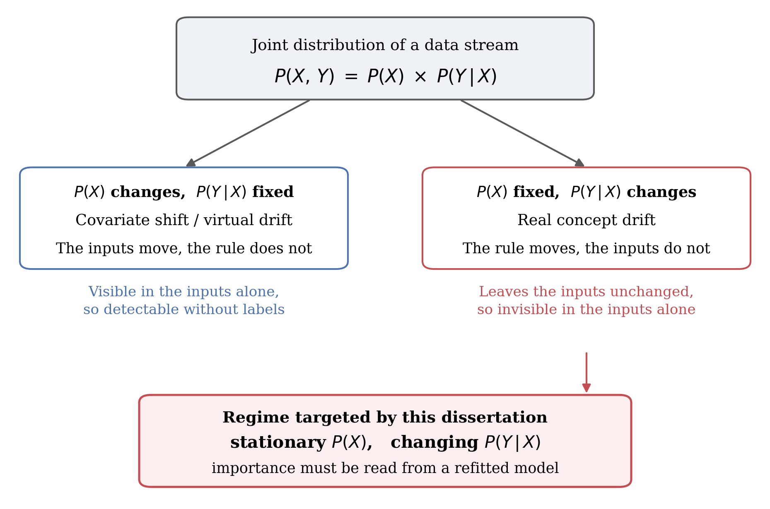
Figure 2.1 Joint-distribution decomposition and drift types
A change in P(X) alone is covariate or virtual drift, visible in the inputs; a change in P(y | X) alone is real concept drift and leaves the inputs unchanged. The shaded box marks the regime targeted here. Conceptual diagram.
Drift is further characterised by its temporal profile. Gama et al. (2014) distinguish sudden drift, in which the concept switches at a point in time; gradual drift, in which old and new concepts are interleaved over a transition period; incremental drift, in which the concept moves smoothly through intermediate states; and recurring drift, in which previous concepts return. Webb et al. (2016) formalise these profiles quantitatively, arguing that qualitative labels conceal differences in drift magnitude and duration. The profile matters for detector design, because a detector tuned to abrupt change may accumulate evidence too slowly for incremental movement, and vice versa (Ditzler et al., 2015).
The practical consequence of drift is model degradation, and business decisions based on the model's outputs deteriorate with it (Žliobaitė, Pechenizkiy and Gama, 2016; Bayram, Ahmed and Kassler, 2022). The operational question is therefore when to retrain, which converts drift detection into a monitoring-cost problem: retraining too often wastes resources, while retraining too late incurs the cost of degraded predictions. Earlier warning directly reduces the second cost.

2.3 Drift detection methods
Detection methods divide broadly into those monitoring the model's error stream and those monitoring the data distribution. Both are reviewed here because they supply the baselines used in this dissertation and because their limitations define the research gap.

2.3.1 Error-based detection
The most widely used detectors monitor a supervised performance signal. DDM models the classifier's error rate as a binomial variable and raises a warning when the rate exceeds its historical minimum by a threshold number of standard deviations (Gama et al., 2004). The Early Drift Detection Method monitors the distance between errors instead, improving sensitivity to gradual drift (Baena-García et al., 2006). ADWIN maintains a variable-length window over the error stream and cuts it whenever two sub-windows exhibit statistically distinguishable means, with guarantees on false-positive and false-negative rates (Bifet and Gavaldà, 2007). The Page–Hinkley test cumulates deviations of the error signal from its running mean (Page, 1954), and further variants apply statistical tests over chunked error streams (Nishida and Yamauchi, 2007) or Hoeffding-bound comparisons (Frías-Blanco et al., 2015).
These methods share two structural limitations. They are reactive by construction, since the error rate can only rise after the model has begun making mistakes, so detection necessarily lags drift onset (Ditzler et al., 2015; Lu et al., 2019). And they require timely ground-truth labels, an assumption often violated in deployment (Sethi and Kantardzic, 2017). Both limitations motivate signals derived from the model itself rather than from its verified errors.

2.3.2 Distribution-based and model-internal detection
A second family avoids the label requirement by monitoring the input distribution directly, including incremental two-sample tests such as the sequential Kolmogorov–Smirnov test of dos Reis et al. (2016) and discriminative approaches such as D3, which trains an auxiliary classifier to distinguish old from new windows (Gözüaçık et al., 2019). These methods detect covariate shift effectively, but are blind by construction to real concept drift under stationary P(X): if only P(y | X) moves, the inputs carry no signature of the change (Webb et al., 2016).
A smaller line of work monitors internal properties of the deployed model. Sethi and Kantardzic (2017) track the density of predictions falling within the classifier's margin, arguing that a rise indicates growing uncertainty and can precede measurable error increase without requiring labels. This establishes a precedent for the present premise: signals extracted from how the model processes data can move before the error rate does. Margin density is, however, a scalar summary; it identifies that something has changed but not which features are implicated, limiting its diagnostic value.

2.4 Variable importance and model explanation
Variable importance methods quantify how much a model relies on each feature, offering a feature-resolved view of model behaviour that scalar signals such as accuracy or margin density cannot provide.
Breiman (2001a) introduces permutation importance alongside the random forest: the importance of a feature is the degradation in predictive performance when its values are randomly permuted. Permutation importance is model-agnostic and intuitive, but inherits known biases, including inflation for correlated predictors and for variables with many categories (Strobl et al., 2007).
Lundberg and Lee (2017) unify several attribution methods under SHAP, which assigns each feature a contribution to each prediction using Shapley values from cooperative game theory. TreeSHAP makes exact computation tractable for tree ensembles, so local explanations can be aggregated into global importance profiles (Lundberg et al., 2020). Covert, Lundberg and Lee (2020) extend the framework to global importance with SAGE, which attributes predictive performance rather than individual predictions. The distinction is material here: attribution over predictions describes what a fixed model does, whereas attribution over loss describes how well its use of each feature matches the current environment.
A critical caveat runs through this literature: explanation methods explain the model, not the world (Rudin, 2019; Molnar, 2020). A SHAP profile computed on a frozen model is a deterministic function of that model and the inputs it receives. Section 3.2.1 develops the consequence formally; in outline, naive importance monitoring on a static deployed model cannot detect pure concept drift, so importance-based detection must be designed with care over which model is explained.

2.5 Importance-based drift detection: an emerging intersection
A small body of work applies model explanation to the drift problem directly. Demšar and Bosnić (2018) compute streaming model explanations and detect drift as change in the explanation stream, demonstrating that explanation-based signals can identify drift and, in some configurations, localise it to specific features. Haug et al. (2022) detect change in local feature attributions over evolving streams, and incremental variants of global importance measures have been proposed to make Shapley-based monitoring feasible online (Muschalik et al., 2023). Collectively this work establishes feasibility.
Three gaps remain. First, the early-warning question is largely unaddressed: existing studies ask whether importance-based detection works, not whether it fires earlier than error-based detection, and lead time is rarely reported as a primary metric. Second, the frozen-versus-refitted distinction is generally implicit rather than analysed: studies recomputing explanations on periodically retrained models conflate the drift signal with the retraining schedule, while studies on static models are structurally limited under stationary inputs. Third, no study identified here takes the reliance structure of the Rashomon set as the monitored object for drift detection.
Several strands of directly relevant work should be acknowledged. Fumagalli et al. (2023) develop an incremental estimator for permutation feature importance on streams and demonstrate it under induced concept drift; their concern is efficient online estimation rather than detection timing. Lee et al. (2023) derive a label-free drift score from SHAP values using a Mahalanobis distance to a reference set, which is closest in spirit to the frozen-model track of the present design. Pawlicki, Kozik and Choraś (2026) report that TreeSHAP attribution distributions can remain stable under a drift that degrades performance, an observation consistent with the structural argument of Section 3.2.1.
These studies sharpen rather than remove the gap addressed here, which is the combination of four things: explicit treatment of the frozen-versus-refitted distinction as a measurement question; lead time relative to measurable degradation as the primary reported quantity; exact monitoring of reliance structure against known ground truth; and a negative control testing whether an alarm depends on the temporal ordering of the stream at all. No claim is made that any single one is unprecedented.

2.6 Rashomon sets and reliance structure
Breiman (2001b) observes that many distinct models frequently achieve near-identical predictive accuracy on the same data, a phenomenon he terms the Rashomon effect. The set of near-optimal models, the Rashomon set, can contain models relying on substantially different features while performing equally well (Fisher, Rudin and Dominici, 2019; Semenova, Rudin and Parr, 2022).
Fisher, Rudin and Dominici (2019) formalise reliance across that set as Model Class Reliance (MCR): for each feature, MCR reports the minimum and maximum reliance over all models in the set. Where single-model importance describes one arbitrary member, MCR bounds describe the entire class of adequate explanations.
This dissertation takes the reliance structure of that class, rather than the formal MCR interval, as the monitored object. Under a stable concept, which models are adequate and which features they must rely upon are properties of the data-generating process, and should be stable across time windows. When P(y | X) moves, models that were adequate cease to be, and the pattern of which feature subsets suffice to predict the label changes with them; that shift may plausibly precede a visible fall in the deployed model's accuracy. What is monitored is the structural pattern, not the reliance values of Fisher, Rudin and Dominici (2019). Section 3.5.4 makes the distinction precise, and no MCR bound is estimated anywhere in this dissertation.

2.7 Benchmark data and evaluation methodology
Empirical drift research relies heavily on synthetic streams with known drift points, because ground truth for drift onset is otherwise unobservable. The rotating hyperplane generator produces real concept drift by rotating a linear decision boundary while the input distribution remains uniform and stationary (Hulten, Spencer and Domingos, 2001); the SEA generator produces abrupt drift by shifting a threshold on a sum of features (Street and Kim, 2001). Losing, Hammer and Wersing (2016) assemble these into a benchmark suite used across the literature, and frameworks such as MOA (Bifet et al., 2010) and River (Montiel et al., 2021) provide reference detector implementations.
The rotating hyperplane stream is methodologically important here: because P(X) is stationary by construction, any detection achieved on it cannot be attributed to covariate shift, isolating the hard case identified in Section 2.2. Conversely, SEA-style threshold drift provides a contrast case in which the set of relevant features does not change.
Evaluation in this field uses three primary quantities: detection delay, the time from true drift onset to detection; false-alarm rate, estimable only where a stable period exists; and, for the early-warning question specifically, lead time relative to the point at which predictive performance measurably degrades (Bifet and Gavaldà, 2007; Gama, Sebastião and Rodrigues, 2013). Sound evaluation further requires prequential, or test-then-train, assessment so that performance estimates are not contaminated by data the model has already seen (Gama, Sebastião and Rodrigues, 2013).

2.8 Synthesis and research gap
The reviewed literature supports the following argument. Concept drift degrades deployed models, and the operationally valuable moment to act is before accuracy visibly falls (Section 2.2). Existing detectors either wait for errors to accumulate, and are therefore reactive and label-dependent, or monitor input distributions and are therefore blind to real concept drift under stationary inputs (Section 2.3). Variable importance provides a feature-resolved signal of model behaviour (Section 2.4), and early work confirms such signals respond to drift in streaming settings (Section 2.5); but that work has not established whether importance signals lead performance degradation, has not disentangled frozen from refitted signals, and has not exploited the reliance structure of the Rashomon set (Section 2.6).
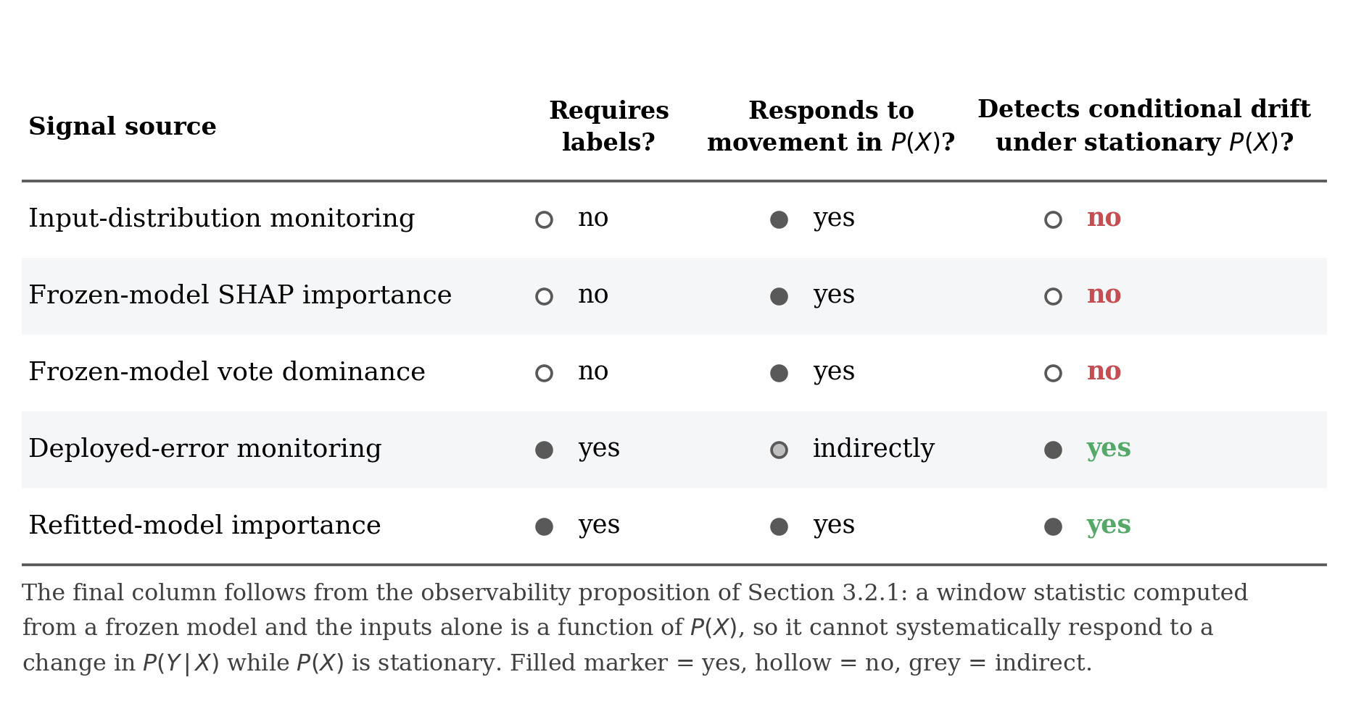
Figure 2.2 Observability of monitoring signal sources
Filled markers denote yes, hollow no, grey an indirect relationship. The final column follows from the proposition of Section 3.2.1. Conceptual diagram.
These gaps motivate the three research questions stated in Section 1.4, together with the scope statement that accompanies them, and they are addressed by the design set out in Chapter 3.

Chapter 3: Methodology

3.1 Overview and research design
This chapter sets out the experimental design: a controlled comparison in which a fixed set of candidate signals and a fixed set of baseline detectors are computed over the same data, under an identical windowing protocol, and evaluated against the same alarm rule and metrics. Because the research questions concern when a signal fires, the data are constructed so that the timing of the underlying change is known.
The research follows a deductive, quantitative strategy: propositions are derived first and then tested through controlled experiment (Saunders, Lewis and Thornhill, 2019). The unit of analysis is the data window and the dependent quantities are timing measurements; predictive accuracy enters only as the reference event against which earliness is judged.

3.2 The measurement problem

3.2.1 Frozen-model attribution under a stationary input distribution
Let f denote a classifier fitted at time t0 and thereafter held fixed, and let φ(f, x) denote a feature-attribution vector computed for f at input x, taken here to be the SHAP vector of Lundberg and Lee (2017). The global importance profile of f over a window W is the mean absolute attribution across the instances in that window:
I(f, W) = (1 / |W|) Σ |φ(f, x)|, x ∈ W
Two properties of this quantity determine what it can detect. The label appears nowhere in the definition of φ(f, x), and f is fixed by assumption, so I(f, W) is a deterministic function of the empirical distribution of X over W and of nothing else. For any two windows from the same input distribution it therefore differs only by sampling variation, whatever change has occurred in P(y | X). This follows from the definitions: real concept drift moves P(y | X) while leaving P(X) unchanged, and frozen-model attribution reads P(X) alone. The explanation remains faithful; it correctly describes a model that has become wrong (Rudin, 2019; Molnar, 2020).
The argument does not depend on the statistic being an attribution. Let S(f0, W) be any window-level statistic computed from the frozen model and the inputs of W, with the label playing no part; the same steps apply, so under stationary P(X) it cannot systematically respond to a change in P(y | X). Ensemble vote dominance, signal S3, is of exactly this form. The proposition also delimits where such statistics remain useful: when the inputs presented to the frozen model change in distribution or realised support, a model-internal statistic can respond without labels, which is the regime the Boolean harness represents.
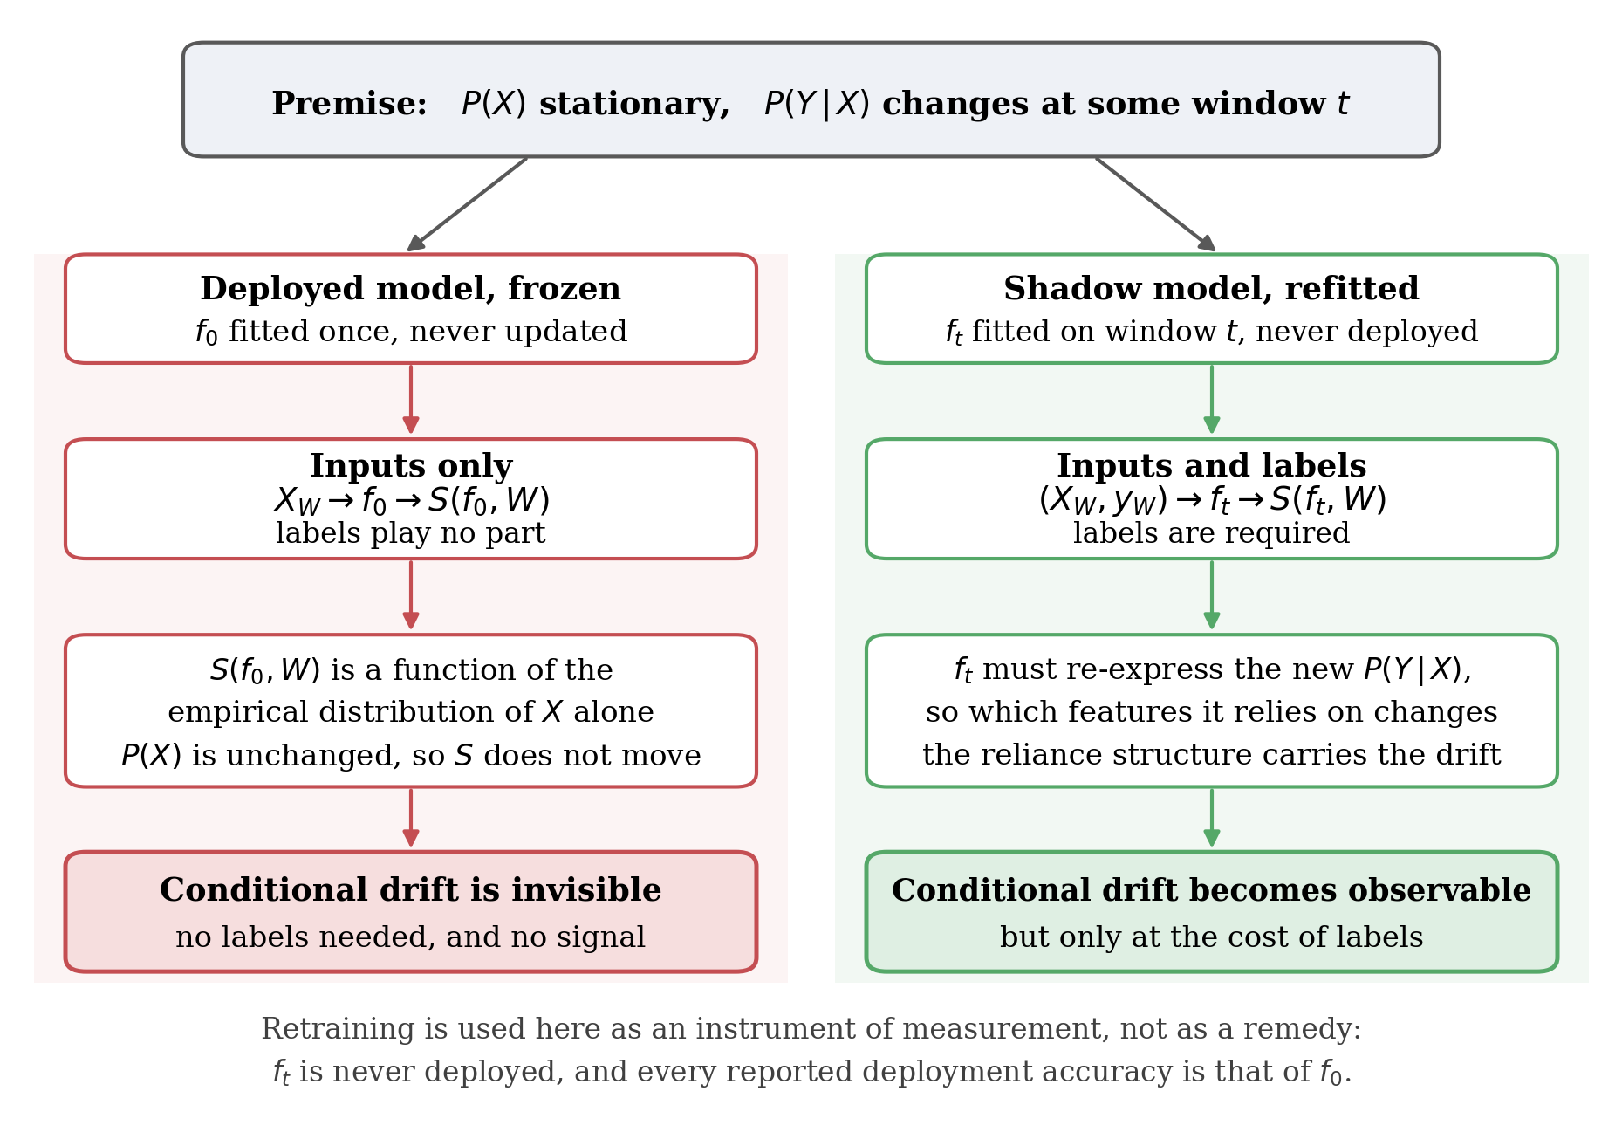
Figure 3.1 Measurement design and drift observability
Under stationary P(X) the frozen model yields window statistics that are functions of P(X) alone; a shadow model refitted on the current window must re-express the new relationship, which makes the change observable but requires labels. Conceptual diagram.
Two measurements, reported in Chapter 4, sharpen the argument. Across the benchmark the largest movement in any single feature's normalised importance was 0.035 for the frozen model against 0.417 under refitting. On the harness the failure is worse than insensitivity: from the twelfth timestep feature D is strictly necessary to any adequate predictor, yet refitted attribution raises D's share from 0.154 to 0.500 while frozen attribution lowers it to 0.025. A monitor reading the frozen signal would conclude that D was becoming less relevant at the moment it became indispensable.
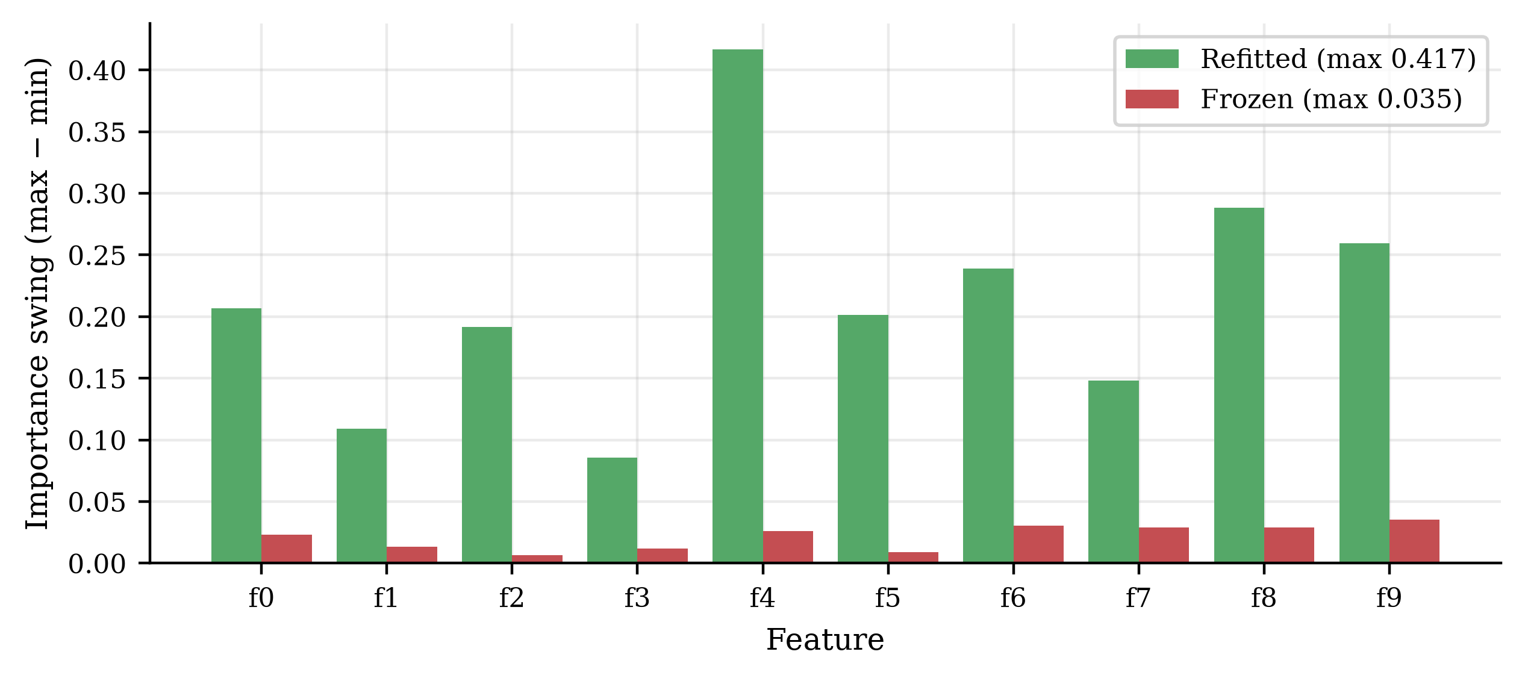
Figure 3.2 Refitted versus frozen feature-importance movement
Per-feature importance swing over the 200 windows of the rotating hyperplane stream. The refitted model reallocates up to 0.417 of its normalised importance share; the frozen model moves by at most 0.035.
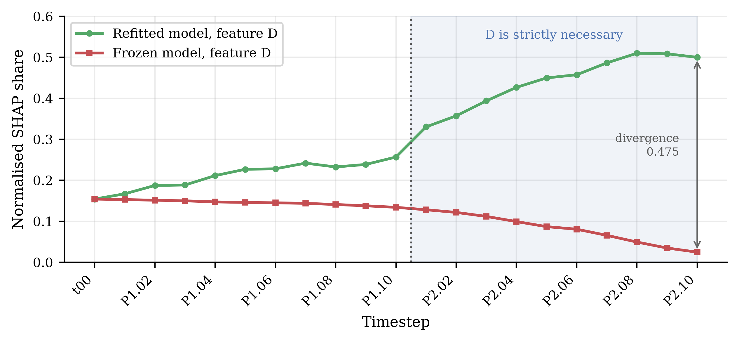
Figure 3.3 Feature D attribution on the Boolean harness
Normalised SHAP share attributed to feature D across the Boolean harness. From P2.01 the ground truth makes D strictly necessary; the refitted model tracks this, the frozen model moves in the opposite direction.

3.2.2 Retraining as an instrument of measurement
The result in Section 3.2.1 rules out one design and prescribes another. If an importance signal is to respond to a change in the input–output relationship, the model being explained must be refitted to the current data.
The role of refitting requires care. In the adaptive-learning literature retraining is a remedy (Gama et al., 2014); here it is an instrument of measurement. The window-local model is never deployed, never scored as deployment performance and never replaces the monitored model. The deployed model f0 remains frozen, and every deployment-accuracy figure reported is that of f0. This separation allows movement in the importance signal to be compared against a fall in deployed performance without the two sharing a retraining schedule, a confound Section 2.5 identifies as unaddressed.

3.3 Data and validation harness

3.3.1 Construction of the Boolean validation harness
Two data sources are used. Measurement code that reports the timing of an event is only as trustworthy as its behaviour on a case where the answer is already known, so the pipeline is validated first against a purpose-built Boolean harness in which the target function, the drift mechanism, its timing and the full reliance structure are derived exactly rather than assumed.
The harness is generated from two latent binary variables, u and v, as Figure 3.4 shows. A and B carry u, so B duplicates A; C and D carry v, so D duplicates C; and E carries the complement of v. The label is the exclusive-or of the latent variables and is therefore recoverable as A XOR C. One timestep comprises all four combinations of (u, v) repeated 25 times, giving 100 rows with a balanced label distribution.
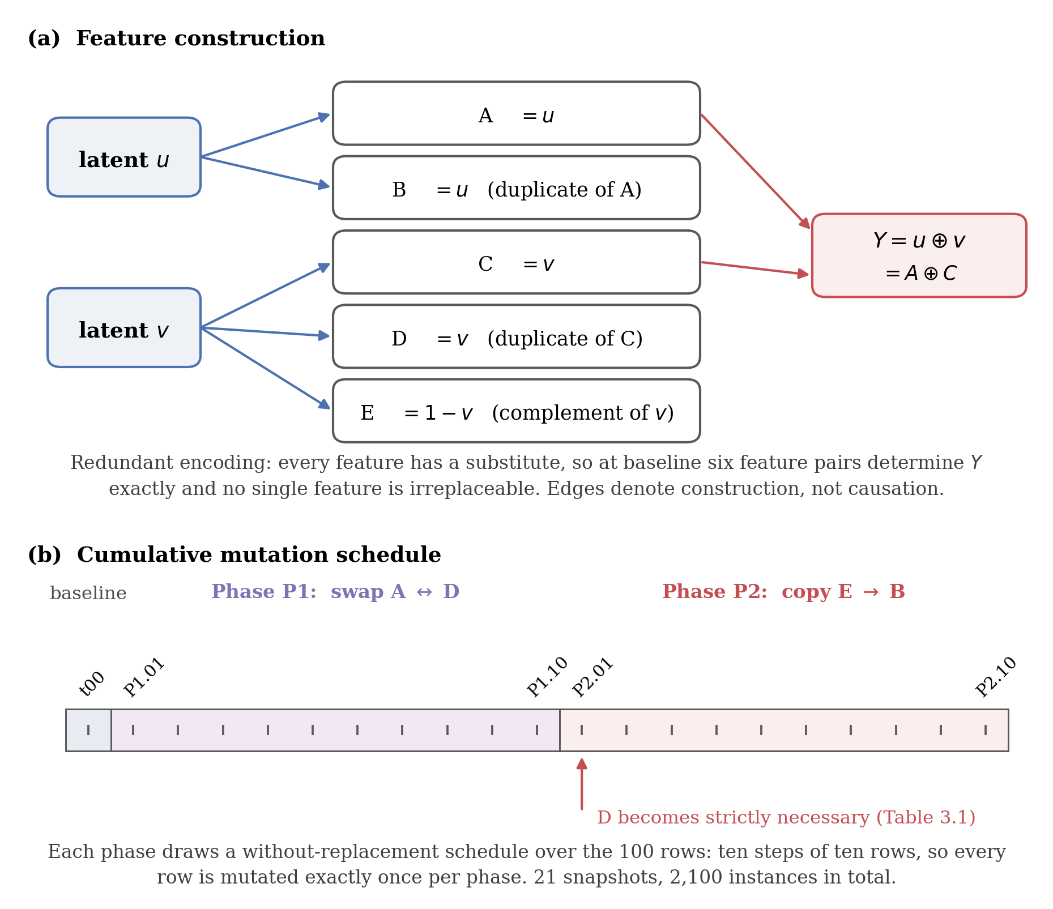
Figure 3.4 Boolean validation-harness construction
Panel (a) derives the five observed features from two latent bits and forms the label; panel (b) shows the cumulative mutation schedule across the 21 snapshots. Conceptual diagram; the timestep at which D becomes necessary is from Table 3.1.
This redundant encoding is the point of the design. At the baseline timestep six distinct pairs of features determine the label exactly — AC, AD, AE, BC, BD and BE — so no single feature suffices and none is irreplaceable, because every feature has a substitute. The harness therefore begins with a set of sufficient feature pairs of known size and known membership, which is the structure Section 3.5.4 proposes to monitor.
Drift is introduced by cumulative cell-level mutation of the feature columns on a without-replacement schedule, so that across each phase's ten steps every row is touched exactly once. Phase P1 exchanges the values of A and D on the scheduled rows; phase P2 copies E over B. This yields 21 snapshots and 2,100 instances. Appendix B gives the full schedule.
The label column is never modified, so any change in the feature–label relationship arises from the features alone rather than from injected label noise. Because an exchange between columns already holding the same value has no effect, the nominal mutation rate of 10% per step corresponds to an effective rate of approximately 5%.

3.3.2 Ground truth and the formal character of the harness
The reliance structure at every timestep is computed rather than asserted. All ten two-feature subsets are exhaustively enumerated, and a pair is recorded as sufficient when no two rows sharing its values disagree on the label. Relevance is defined here from membership of at least one sufficient pair, singleton sufficiency is checked separately, and strict necessity is tested by removing each feature and asking whether the remaining features still determine the label. Necessity in this sense is the structural counterpart of a feature on which every adequate model must rely; no Model Class Reliance bound is estimated.
Table 3.1 Exact Boolean-harness reliance structure
Sufficient pairs are the two-feature subsets determining the label exactly, with the count in parentheses. All ten two-feature subsets are exhaustively enumerated at every timestep, and singleton sufficiency is checked separately. Relevance is membership of at least one sufficient pair; strict necessity is tested by removing a feature and asking whether the remainder still determines the label.
Timestep | Sufficient pairs | Relevant features | Necessary
t00 | AC AD AE BC BD BE (6) | A B C D E | none
P1.01 to P1.09 | AD BC BE (3) | A B C D E | none
P1.10 | AB AD BC BE CD DE (6) | A B C D E | none
P2.01 to P2.09 | AD CD DE (3) | A C D E | D
P2.10 | AD BD CD DE (4) | A B C D E | D

Three events are therefore known in advance and serve as reference times. The set of sufficient feature pairs contracts from six to three at the first mutation step. It expands back to six at the end of phase P1. And at the first step of phase P2 feature B leaves the relevant set entirely while feature D becomes strictly necessary, the first point at which any feature is irreplaceable.
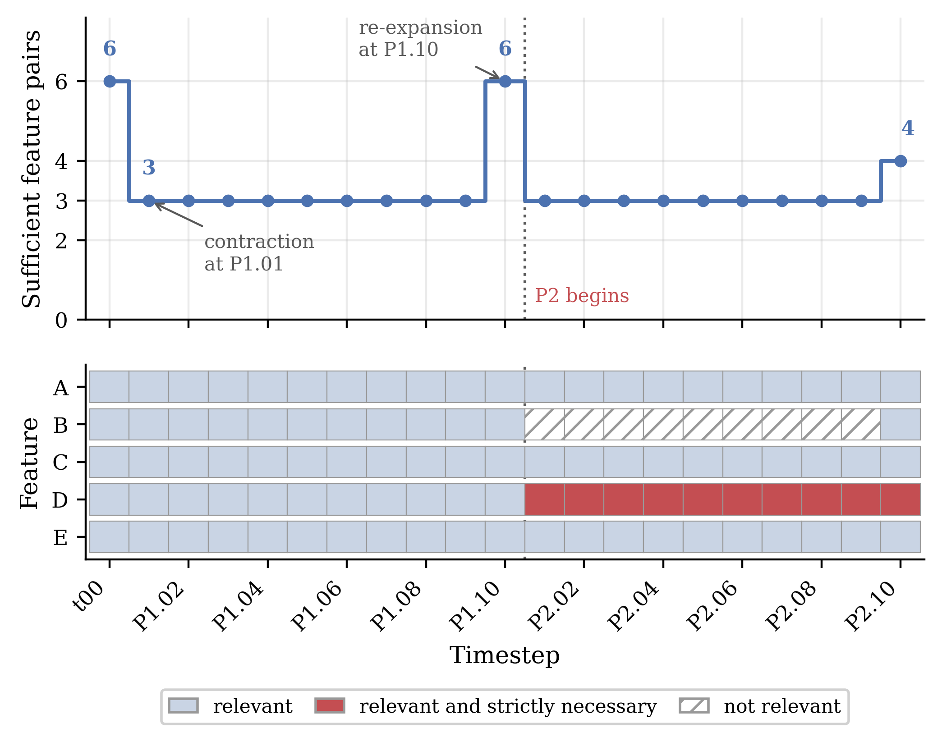
Figure 3.5 Evolution of Boolean reliance structure
The upper panel plots the number of feature pairs determining the label exactly; the lower panel marks each feature as relevant, relevant and strictly necessary, or not relevant.
The formal character of the drift requires an honest statement. No feature vector in the harness maps to conflicting labels, so the conditional relationship remains a consistent deterministic function throughout; what moves is the realised support of the input distribution. The harness is consequently not an instance of pure real concept drift, and is not offered as one; the rotating hyperplane stream serves that role.
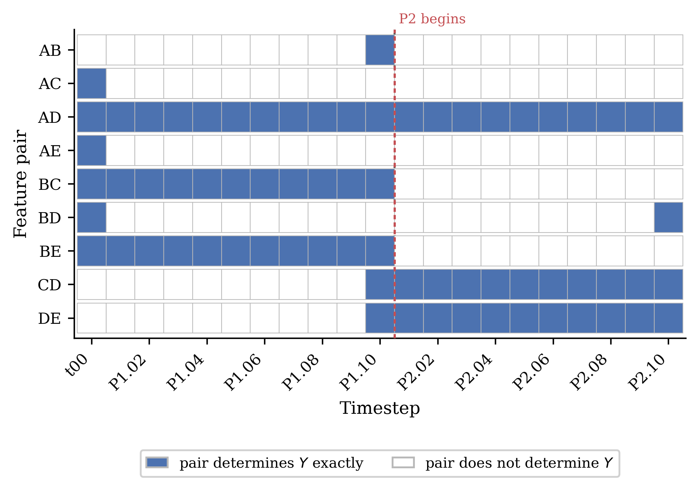
Figure 3.6 Membership of sufficient feature pairs
A filled cell indicates the pair determines the label exactly at that timestep. Rows are every pair sufficient at any timestep.
What it provides instead is a controlled test of an equally necessary proposition: that the candidate signals track change in the reliance structure, with that structure known exactly at every step. Its decisive property, verified by assertion, is that a perfect predictor exists at every timestep, so a refitted model holds accuracy at 1.00 while the frozen model degrades to 0.50. Any movement in the refitted signal here is therefore a pure reliance-structure signal, with no accuracy loss for it to proxy.
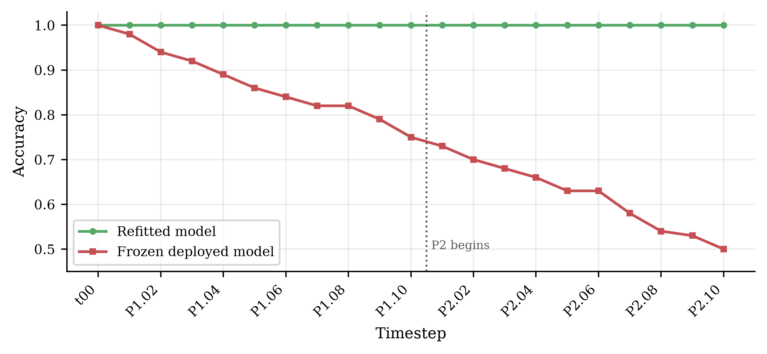
Figure 3.7 Refitted and frozen harness accuracy
A perfect predictor exists at every timestep, so the refitted arm holds accuracy at 1.00 while the frozen model decays to 0.50.

3.3.3 Rotating hyperplane primary stream
The rotating hyperplane stream is the primary experimental vehicle. It is generated by rotating a linear decision boundary through a feature space whose input distribution is uniform and stationary (Hulten, Spencer and Domingos, 2001), and is used here as distributed by Losing, Hammer and Wersing (2016): 200,000 instances, ten continuous features and a binary label, with a class distribution of 100,065 to 99,935.
Its methodological value lies in what it excludes. Because the input distribution does not move, no detection achieved here can be attributed to covariate shift; any signal that fires must be responding to a change in the conditional relationship. The stream therefore isolates the case Section 2.2 identifies as hardest, and neutralises the confound Lu et al. (2019) identify as pervasive in real data.
One property requires explicit handling. The boundary rotates continuously rather than switching at discrete moments, so there is no single drift onset and detection delay measured against a point onset is undefined; Section 3.8 specifies the alternative reference event. The harness, whose mutation steps are exactly dated, supplies the case in which detection delay is measured directly.
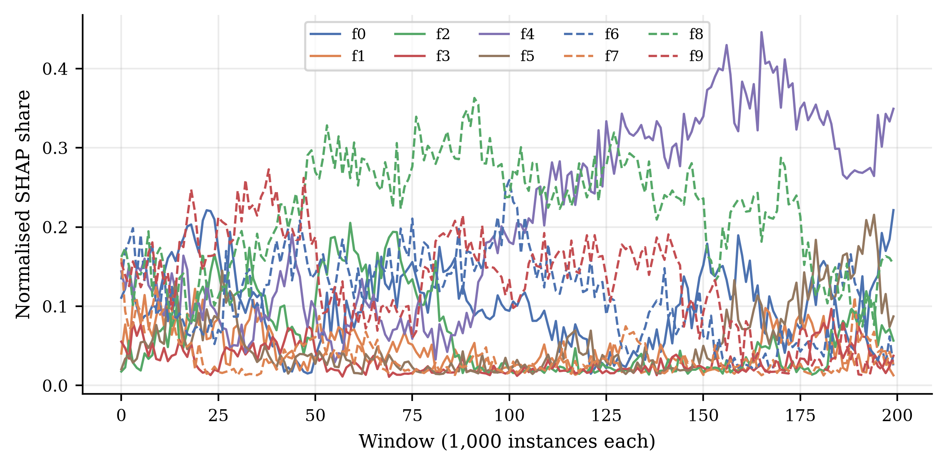
Figure 3.8 Refitted SHAP profiles on the hyperplane stream
Normalised SHAP share per feature across the rotating hyperplane stream under per-window refitting. The reliance structure reorganises continuously, consistent with a rotating boundary.

3.4 Experimental pipeline
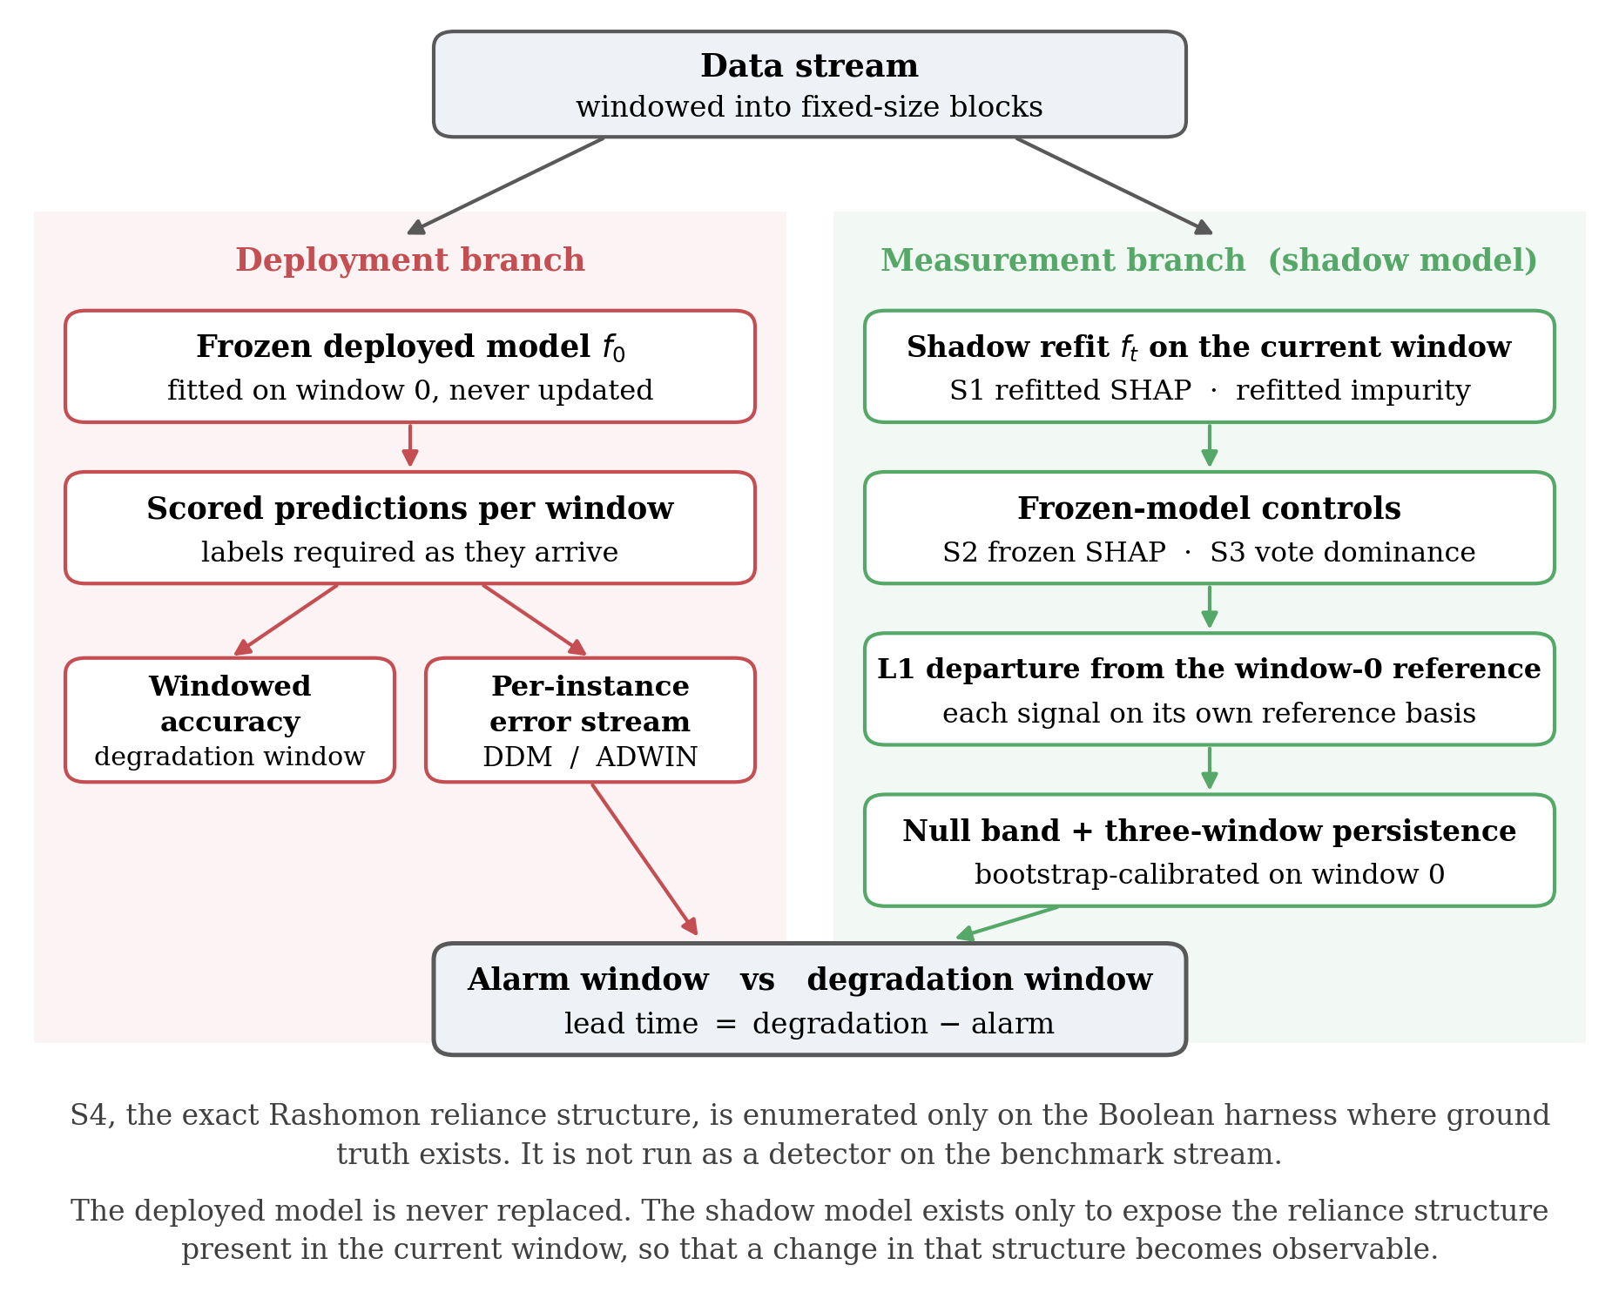
Figure 3.9 Experimental monitoring pipeline
The deployment branch scores the frozen model and supplies both the degradation reference and the error stream monitored by DDM and ADWIN; the measurement branch refits a shadow model that is never deployed. Conceptual diagram.

3.4.1 Windowing and evaluation protocol
On the rotating hyperplane stream the data are partitioned into consecutive non-overlapping windows of 1,000 instances, yielding 200 windows. The window length trades resolution against stability: shorter windows locate a change more precisely but yield noisier importance estimates. On the Boolean harness the natural window is the snapshot itself, the 100 rows of one timestep, so windowing follows from the construction rather than being chosen.
Evaluation follows the prequential, or test-then-train, protocol (Gama, Sebastião and Rodrigues, 2013). A deployed model f0 is fitted on the first window and frozen; every subsequent window is used to score f0 before it is used to compute any signal, so no performance estimate is contaminated by data the scoring model has seen. Attributions on the benchmark are computed on a random subsample of 200 instances per window; on the harness all 100 rows are used.

3.4.2 Base learner and configuration
The base learner throughout is a random forest (Breiman, 2001a; Pedregosa et al., 2011). It is a tree ensemble, so exact Shapley attributions are computable in polynomial time via TreeSHAP (Lundberg et al., 2020); its vote structure is directly observable, making the vote-dominance signal available without auxiliary construction; mean decrease in impurity is defined natively for it; and it is the standard batch learner in this literature, so results remain comparable with published work.
Two configurations are used. The benchmark forest comprises 100 trees at library defaults; the harness forest comprises 300 trees, because vote dominance is quantised in units of one over the number of trees and the harness deliberately contains duplicated columns whose tie-breaking behaviour is the object of interest. Appendix A records both configurations in full.

3.5 Candidate drift signals
Four signals are computed per window, each converted to discrete alarms by the common rule of Section 3.7. The first is the importance signal that Section 3.2.1 forces; the second is its frozen-model counterpart, retained as a control rather than proposed as a detector; the third exploits ensemble structure and requires no labels; the fourth monitors the reliance structure itself and is scoped to the harness alone.

3.5.1 S1 Importance departure under refitting
For each window a model is refitted on that window alone and its importance profile computed and normalised to sum to one. The signal is the L1 distance between the current profile and the reference profile taken from window 0. Because both lie on the probability simplex, half the L1 distance equals their total-variation distance, so quoted figures should be halved before being read as a share of importance mass reallocated.
The signal is defined for two importance measures: a SHAP variant using normalised mean absolute attribution, and an impurity variant using mean decrease in impurity. The two arms use them differently, and the difference is stated here to avoid overstating the programme. On the Boolean harness both variants are computed and reported side by side, so that a detection cannot be an artefact of one importance measure. On the rotating hyperplane benchmark the reported S1 trajectory is the SHAP variant alone; no benchmark impurity time series was computed, and none is reported.
S1 answers whether the features carrying the relationship have changed. It requires labels, because refitting requires labels, and it requires the refitting that Section 3.2.2 characterises as measurement rather than remediation.

3.5.2 S2 Frozen-model importance departure, as a control
The same L1 departure is computed on the frozen deployed model, whose attributions change only through the input distribution. Section 3.2.1 establishes that this quantity cannot respond to pure conditional drift. It is retained as a control because it quantifies how badly the naive strategy performs, and because, needing neither labels nor refitting, it is the strategy a practitioner would most plausibly adopt by default.

3.5.3 S3 Ensemble vote dominance
Vote dominance is computed from the individual trees of the frozen forest. Every tree casts a hard predicted label per instance, and dominance is the share voting with the majority: one denotes unanimity, one half an evenly split ensemble. Hard votes are used because the forest's own prediction averages class probabilities and so discards the disagreement structure this signal captures.
The window-level summary differs between the arms, because a statistic informative on one is degenerate on the other. On the harness the frozen forest votes unanimously on every baseline row, so the proportion not unanimous begins at exactly zero and any departure is a signal. On the benchmark that statistic already stands at approximately 0.99 and saturates, so mean dominance is used, with its reference estimated out of bag for the reason given in Section 3.7.2. Section 3.2.1 constrains what S3 can achieve: computed from the frozen forest and the window inputs without labels, it cannot systematically track movement in P(y | X) where the generator holds P(X) fixed, so silence on the benchmark is predicted. On the harness the mutation moves the realised support, so disagreement can respond. S3 is therefore a label-free diagnostic of input change relative to the frozen model.
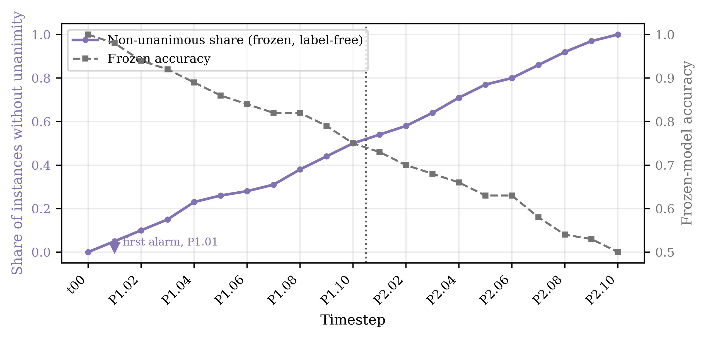
Figure 3.10 Frozen-ensemble disagreement on the Boolean harness
Share of instances on which the frozen ensemble is not unanimous on the Boolean harness, plotted against frozen-model accuracy. The signal departs from zero at the first mutation step, requiring no labels.

3.5.4 S4 Exact sufficient-subset and reliance structure
The fourth signal monitors the structure of the adequate model class, and its relationship to the Rashomon-set literature must be stated precisely. Fisher, Rudin and Dominici (2019) define the Rashomon set as the models whose loss lies within a tolerance of the best achievable loss, and Model Class Reliance reports the minimum and maximum reliance on each feature across it. What is computed here is neither that set nor that interval. The signal is an exact sufficient-subset analysis of the data: which of the ten two-feature subsets determine the label, which features are relevant by membership of at least one sufficient pair, and which are strictly necessary under leave-one-out removal. It is motivated by Model Class Reliance, but no predictive model is enumerated under a loss tolerance and no reliance bound is estimated anywhere in this dissertation. Dong and Rudin (2020) extend the framework to the joint structure of reliance across features.
S4 is scoped to the Boolean harness by design. There the features are binary and the label is a deterministic function of them, so all ten two-feature subsets can be enumerated exhaustively at every timestep, with singleton sufficiency and leave-one-out necessity checked alongside them. On the rotating hyperplane the adequate class would have to be approximated by sampling models within a loss tolerance; that approximation was not performed and no sampled result is reported. S4 accordingly carries no benchmark alarm, no benchmark lead time and no entry in the benchmark permutation control.

3.6 Baseline detectors
Two established error-based detectors provide the comparison. DDM models the error rate as a binomial variable and signals when it exceeds its historical minimum by a threshold number of standard deviations (Gama et al., 2004); ADWIN maintains an adaptive window over the error stream and cuts it when two sub-windows differ significantly in mean (Bifet and Gavaldà, 2007). Both are used as implemented in River (Montiel et al., 2021) at library defaults, reported in Appendix A. Tuning them per stream would improve their measured performance but compromise the comparison, since the candidate signals are not tuned either.
Each detector receives the frozen model's per-instance binary error stream in stream order, so baselines and candidate signals are evaluated against the same model over the same instances in the same sequence. As a check they are also run over the refitted model's error stream; on the harness that stream contains no errors and neither detector fires, confirming the separation claimed in Section 3.3.2.

3.7 From signal to detection: the null-band rule
The baseline detectors emit discrete alarms; the candidate signals are continuous series, so a rule is required to convert a series into alarms. A threshold set by inspecting the results would invite the objection that it was chosen to flatter the signal, and one set from the dispersion of the signal over time conflates refitting variability with drift. The rule adopted calibrates a threshold against variation measured under an unchanged concept, then subjects every alarm to a negative control. The band is not a significance threshold; no distributional assumption is made and no probability is attached to a crossing.

3.7.1 Calibrating the null band
The baseline model is refitted repeatedly on data whose concept has not changed and the importance profile computed for each. The null band is the largest L1 departure of any refit from their common mean; an alarm is raised at the first window whose departure exceeds the band and remains above it for three consecutive windows.
On the harness this calibration does measurable work, because duplicated and complementary columns lead a forest to allocate importance arbitrarily between substitutes. The null band is 0.103 for the impurity variant and 0.071 for the SHAP variant, on a scale whose maximum is two. The impurity departure at the first mutation step is 0.059, inside the band, so the signal correctly does not fire; any lower threshold would have recorded tie-breaking noise as an earlier detection.
The two arms require different procedures. The harness mutates one persistent table of 100 rows in place, so varying the forest seed on the identical baseline table isolates the nuisance term exactly. The benchmark draws 1,000 fresh instances per window, so both the sample and the fit differ between windows of the same concept; a seed-only band underestimates between-window variability and causes every signal to cross at the first window. The reference window is therefore resampled with replacement as well as refitted, across 100 bootstrap replicates.
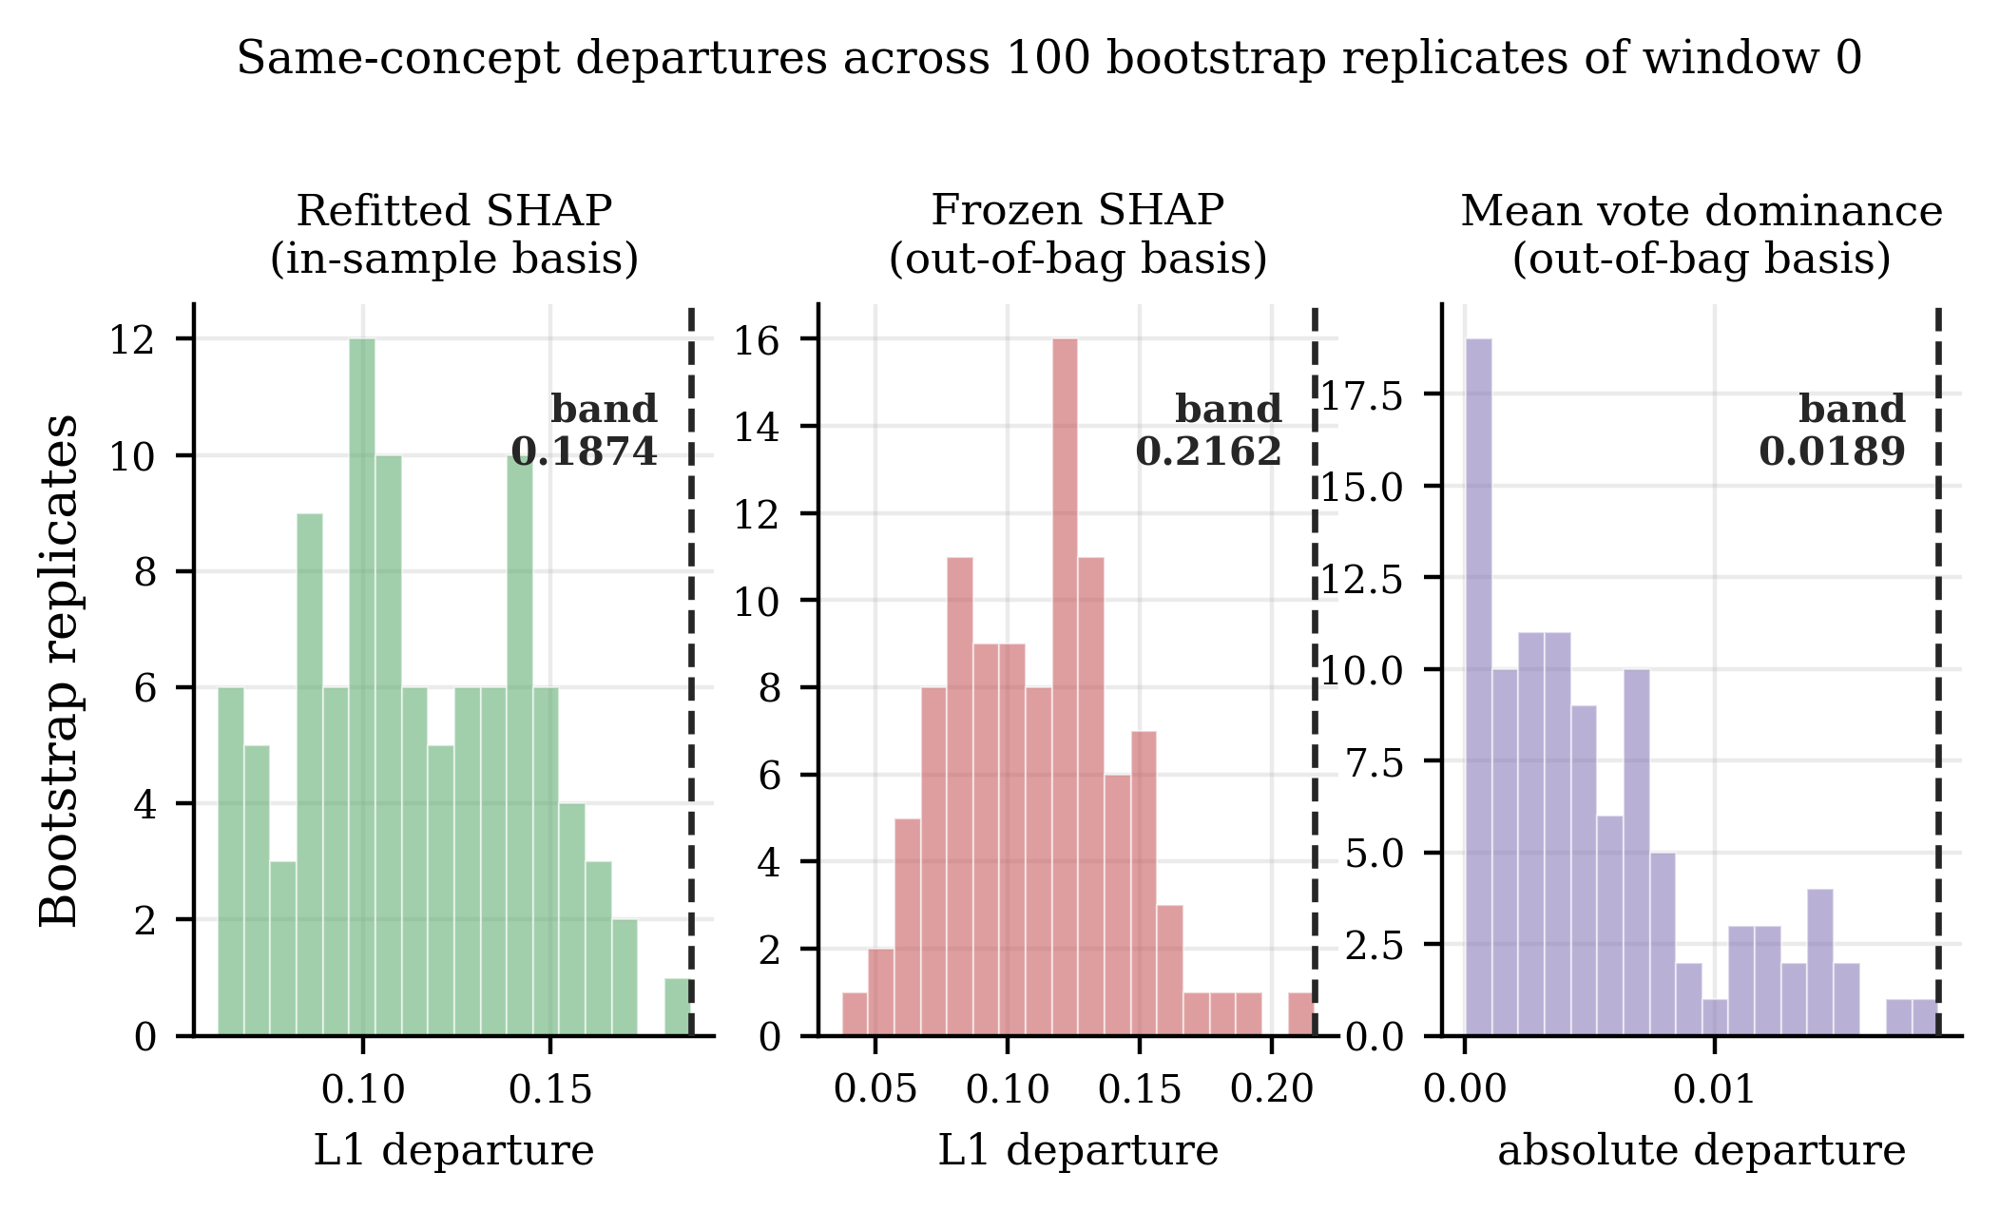
Figure 3.11 Bootstrap calibration of benchmark null bands
Same-concept departures across 100 bootstrap replicates of window 0 on the rotating hyperplane stream, each signal measured on the basis against which it is later tested. The dashed line marks the adopted null band, the largest departure observed under an unchanged concept.

3.7.2 Matching the reference to the measurement
A calibrated band is meaningful only if the reference and the signal are measured the same way, and the candidate signals divide on this point. The refitted signal explains a model fitted on window w using the instances of window w, so it is in sample by construction and its reference is computed in sample. Frozen SHAP L1 and mean vote dominance evaluate the frozen model on unseen windows, so their references are computed out of bag.
Neglecting this distinction invalidates a signal outright, and the magnitude is recorded because it forced the correction. Mean dominance measured in sample gives a reference of approximately 0.937 against approximately 0.724 out of bag, an offset an order of magnitude larger than either band: a forest is more unanimous on the rows it was fitted to, and that optimism is unrelated to drift. Against the in-sample reference the earliest deviations reproduce the offset and cross immediately; against the out-of-bag reference they sit well inside the band. The in-sample construction therefore manufactures a first-window alarm on any stream, and its result is superseded.
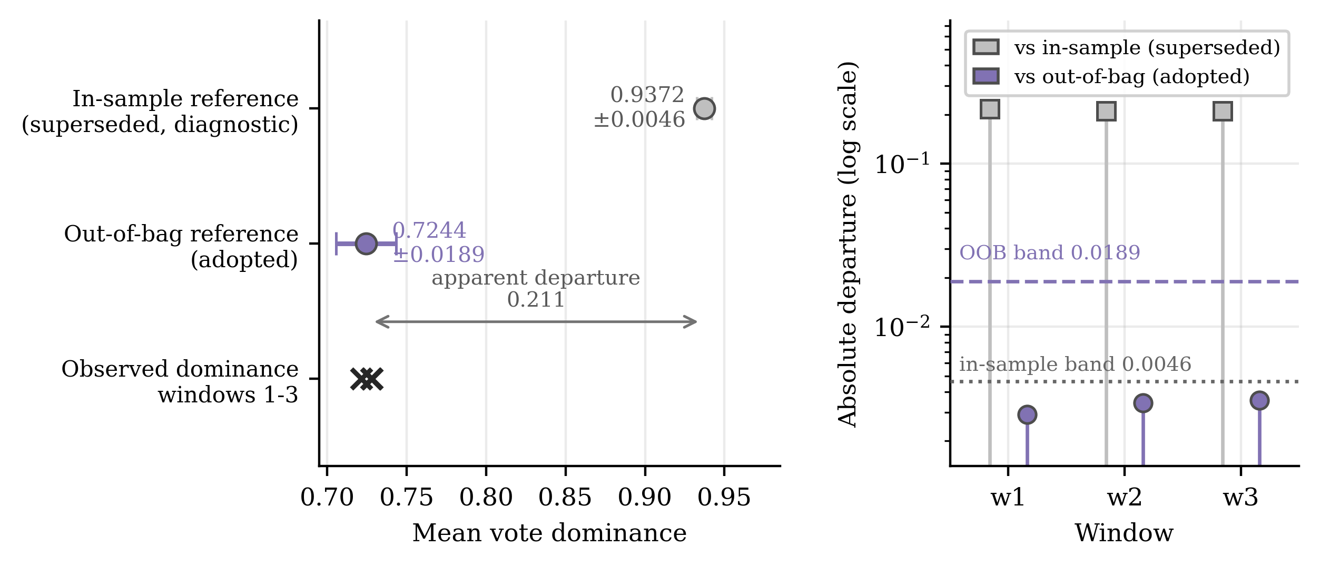
Figure 3.12 In-sample versus out-of-bag dominance calibration
Left: the two candidate references against the dominance observed in windows 1 to 3. Right: the resulting departures on a logarithmic axis against each band. The in-sample reference is superseded and shown for diagnosis only.
On the harness the same construction is exact rather than optimistic: the frozen forest votes unanimously and correctly on all four baseline feature vectors, so the optimism gap is exactly zero. Appendix B records the verification.

3.7.3 Permutation as a negative control
A calibrated threshold establishes that a signal moved further than same-concept variation would carry it, but not that the movement had anything to do with the order in which the stream arrived. The control adopted reruns the analysis on a copy of the stream whose temporal ordering has been destroyed by permutation. Two procedures are required, because the two families consume different inputs and are not equivalent in strength.
For the baseline detectors, the frozen model's binary error stream is permuted and nothing is refitted, preserving the total number of errors exactly so the permuted stream differs only in ordering. For the candidate signals, the instance order of the paired data is permuted jointly and the pipeline recalibrated and rerun; finite-window composition still varies by sampling, and the newly fitted frozen model need not have the same error rate as the chronological one.
Neither procedure estimates a false-positive rate. Three error-stream permutations are run for the detectors and one joint permutation for the candidate signals; no reference distribution is constructed. The control supports a qualitative reading only: an alarm on the permuted copy at or near its chronological window cannot be read as evidence about temporal ordering, whereas a large separation is consistent with dependence on it. A large separation does not establish that a signal produces no false alarms, and the band is a maximum over bootstrap draws applied across 200 windows without family-wise control.
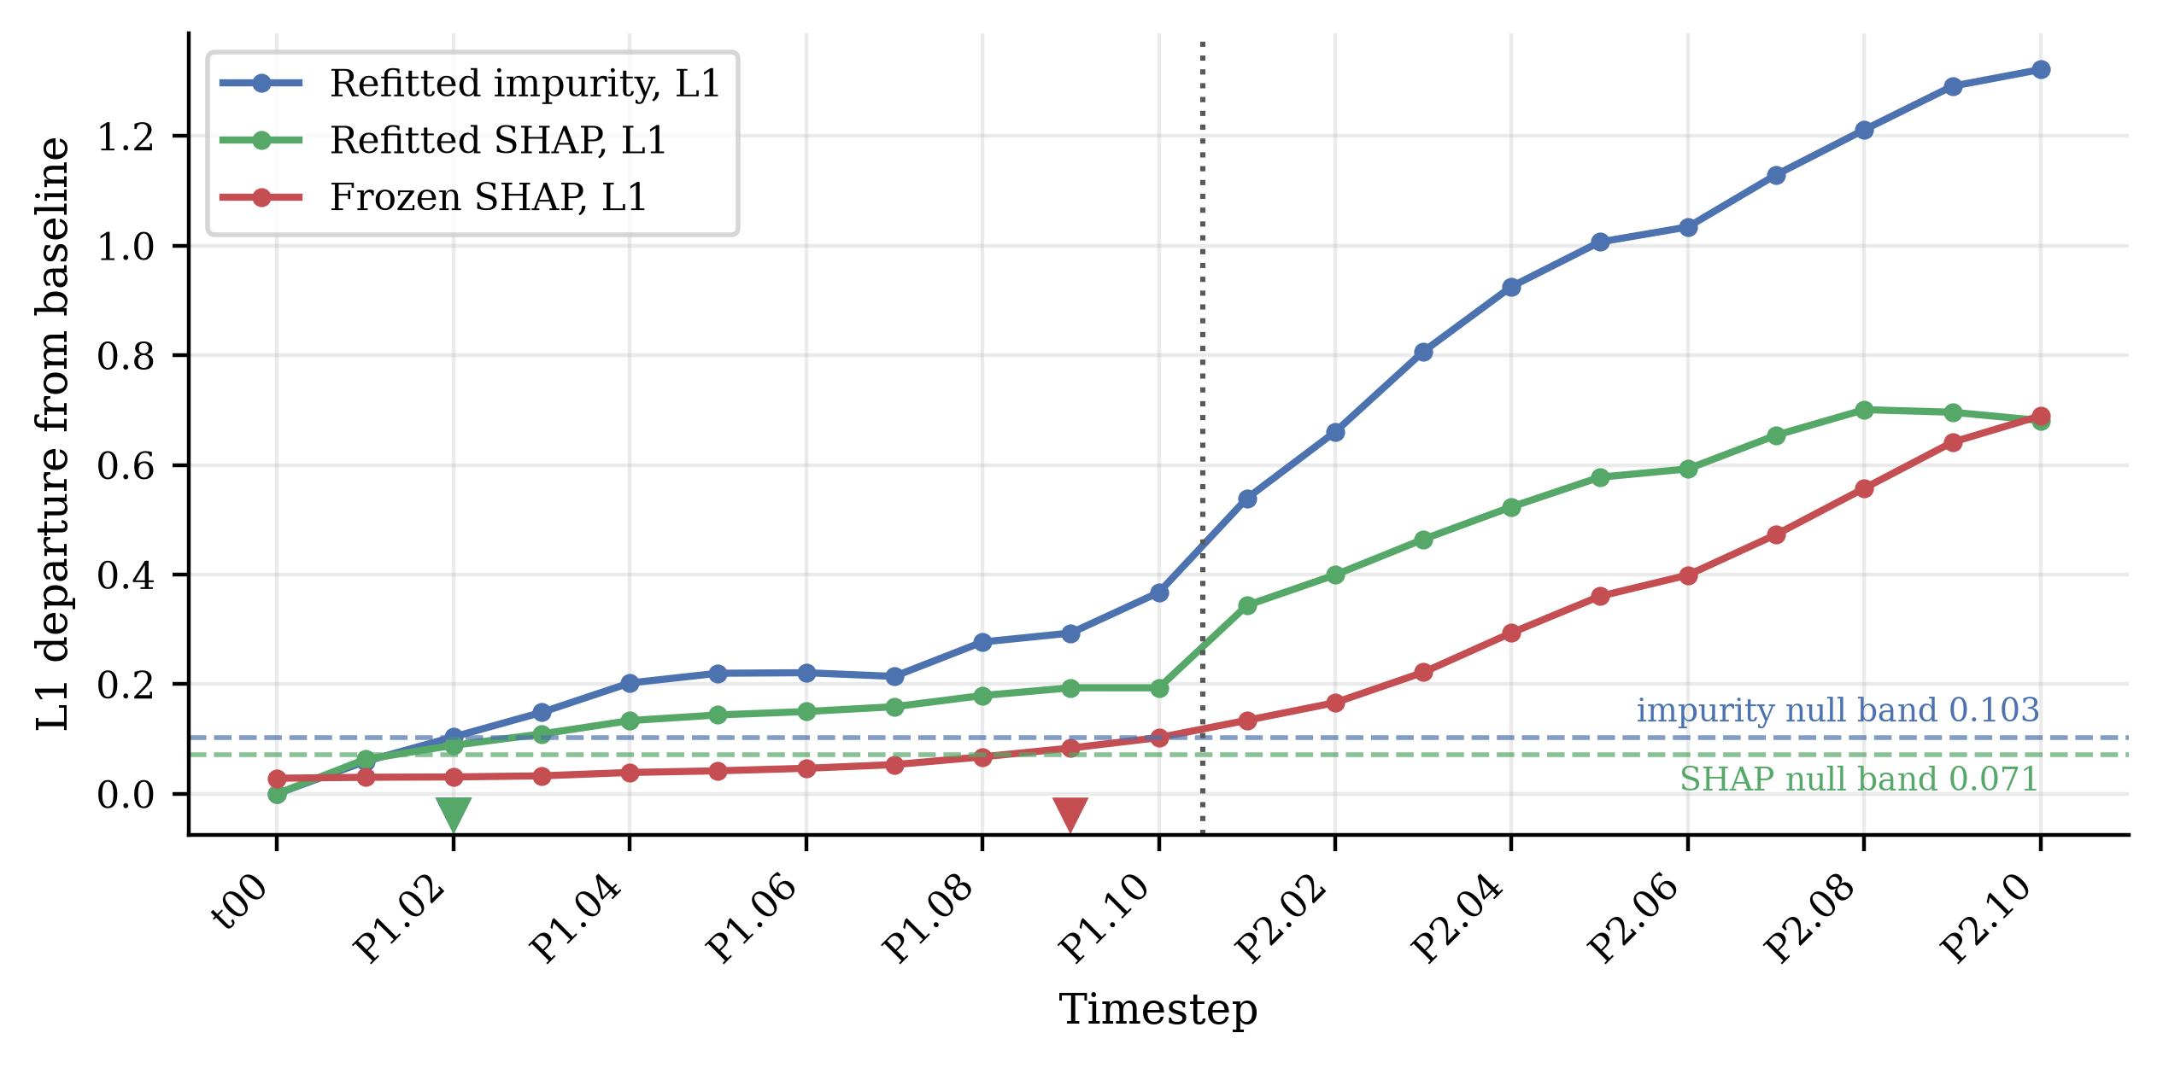
Figure 3.13 Importance departures on the Boolean harness
L1 departure of each importance signal from the baseline profile, against null bands estimated from refits on unchanged data. Markers show first crossing; the impurity signal correctly does not fire at P1.01.

3.8 Evaluation metrics
Three quantities are reported, following the conventions of the stream-learning literature (Bifet and Gavaldà, 2007; Gama, Sebastião and Rodrigues, 2013).
- Detection delay. The number of windows between the reference event and the first alarm. On the harness the reference events are the scheduled mutation steps and the two structural transitions of Section 3.3.2, all exactly dated. The measure is not computed on the benchmark stream, where continuous rotation leaves no point onset.
- False-alarm behaviour. On the harness the null band provides a stable-period reference directly. The benchmark stream contains no stable period at all, because rotation begins with the first instance and never stops, so the permuted copies of Section 3.7.3 supply the only stationarised comparison available and are reported as a negative control rather than an estimated false-alarm rate.
- Lead time. The windows between the first alarm and the point at which the deployed model's performance measurably degrades; the primary quantity for RQ2. The degradation point is the first window at which the frozen model's accuracy falls more than 0.02 below a reference level and remains below for three consecutive windows, and lead time is the degradation point minus the alarm point. On the benchmark, window 0 trains the deployed forest and is excluded from every signal and detector stream, so timings are measured over the 199 post-deployment windows. On the harness, t00 is included in the detector error stream so that DDM and ADWIN initialise on unmutated data.
The reference level is estimated out of bag on the reference window rather than from any post-deployment window. The deployed configuration is refitted under the identical seed with out-of-bag scoring enabled, its trees and predictions verified unchanged so that the deployed model is not altered. It is treated as an internal estimate rather than an exact measure, and no directional bias is assumed.
This avoids a post-hoc choice. Any span of observed windows is selected after inspecting the accuracy trace, and different admissible spans yield materially different degradation points: some are circular, and those that are not still disagree enough to move the point by several windows. An out-of-bag estimate uses only training data and is available before any post-deployment window is observed. Defining lead time against measured degradation also resolves the difficulty of Section 3.3.3 and matches the operational question.
The role of repeated fitting is narrower than replication. On the harness eight forests are refitted at every timestep and their profiles averaged; on the benchmark the bootstrap replicates calibrate the null bands only, and the signal trajectories are single realised series under one seed. Neither arm varies the seed governing the stream, so both rest on a single realisation and timings are single-run point estimates.

3.9 Experimental programme
On the Boolean harness, all four signals and both detectors are computed across the 21 snapshots with the two-feature reliance structure enumerated exhaustively at each step, validating the measurement code and demonstrating the S4 mechanism against exact ground truth. On the rotating hyperplane, the S1 and S2 importance tracks, the S3 dominance signal and both detectors are computed across 200 windows under the alarm rule of Section 3.7; S4 is not computed there. Both detectors run at River defaults on both arms, and no parameter was altered after any result was observed.

3.10 Reproducibility and computational environment
All experiments run under Python 3.12 in an isolated virtual environment, using scikit-learn (Pedregosa et al., 2011), the reference SHAP implementation (Lundberg et al., 2020) and River (Montiel et al., 2021). Appendix A records the exact package versions, seeds, forest configurations and detector parameters. The benchmark data are used as distributed by Losing, Hammer and Wersing (2016) with no preprocessing beyond parsing; the harness is generated by the procedure in Appendix B. Both notebooks are executed end to end in a single pass before the results in Chapter 4 are taken from them.

3.11 Ethical considerations
The research involves no human participants, no personal data and no data collected from individuals. All data are either generated synthetically for this dissertation or drawn from openly published benchmark datasets distributed for research use. The project therefore falls outside the scope of the primary-research protocols requiring ethical approval, and was confirmed on the agreed dissertation proposal form as not requiring research ethics approval; that form was countersigned by the project supervisor on 22 June 2026.
The use of generative AI tools during the preparation of this dissertation is recorded in the accompanying declaration, in accordance with the module requirements.

3.12 Limitations of the design
Eight limitations constrain the interpretation of the results. They are properties of the design rather than of the findings, and Chapters 5 and 6 refer back to this section.
- Single learner family. All signals are computed over random forests. S3 depends on ensemble vote structure and S4 on the notion of a set of adequate models, so no claim of learner-independence is made.
- S4 is exact on the Boolean harness only. The sufficient-pair and reliance structure is enumerated exhaustively over all ten two-feature subsets there, which is the strongest form in which the mechanism can be demonstrated, but it is not estimated on the benchmark stream and no sampled approximation was performed. Evidence for S4 rests on one arm.
- Two synthetic sources. Ground truth for drift timing is available only where the data are constructed, which is what makes the timing questions answerable. The cost is external validity: performance on generated data does not establish performance on operational data.
- Label availability. The baseline detectors and S1 all require labels, the former to compute the error stream and the latter to refit. In deployment labels frequently arrive late or not at all (Sethi and Kantardzic, 2017), so the comparison assumes a condition favourable to the baselines and to S1.
- Fixed window length on the benchmark stream. Signal resolution depends on window length and the main results are computed at a single length of 1,000 instances, so conclusions about delay and lead time are expressed in windows and should be read in that unit.
- No independent multi-stream replication. Each arm rests on a single realisation of its stream. The repeated fitting of Section 3.8 calibrates the null bands; it does not replicate the timing measurement across independently generated streams. A difference of one or two windows should not be read as established.
- Empirical calibration rather than a formal test. The null band describes observed variation under an unchanged concept; it is not a significance threshold and no probability is attached to a crossing. The permutation control is a negative control over three error-stream permutations and one joint permutation, not an estimate of a false-positive rate; for the candidate signals it does not hold the deployed model's error rate fixed.
- Arm-specific S3 summary. The disagreement statistic is summarised differently across the two arms because the fraction not unanimous saturates on the benchmark stream, which limits cross-stream comparability of S3.

Chapter 4: Results and Analysis

4.1 Overview
Section 4.2 reports the Boolean validation harness, where the drift schedule and reliance structure are known exactly and the arm functions as a correctness check on the measurement code. Section 4.3 reports the rotating hyperplane stream, which carries the substantive answers because its drift is generator-defined real concept drift under a stationary input distribution. Section 4.4 answers the research questions and Section 4.5 summarises.
Two conventions apply throughout. Timings on the benchmark stream are reported as lead time relative to measured performance degradation rather than as detection delay, because continuous rotation gives the stream no discrete drift onset; detection delay is reported only for the harness. All timings are single-run point estimates: as Section 3.12 records, neither arm replicates its timing measurement across independently generated streams, so no uncertainty interval accompanies any figure below.

4.2 Boolean validation-harness results
The harness exists to establish that the measurement code recovers a reliance change known to be present. Across all 21 snapshots the refitted forest classifies the harness perfectly, so refitted accuracy is constant and any movement in a refitted importance signal cannot be a proxy for a change in achievable accuracy. As Section 3.3.2 sets out, the harness is not an instance of pure real concept drift: what moves is the realised support of the input distribution.
The clearest single observation concerns feature D, which the construction makes strictly necessary from the twelfth timestep onward. Under refitting, D's share of normalised importance rises from 0.154 at baseline to 0.500. Under the frozen model, the same share falls from 0.154 to 0.025. The frozen signal therefore moves opposite to the change in the underlying relationship, which is what Section 3.2.1 predicts rather than an anomaly.
Table 4.1 First responses on the Boolean harness
Null bands are estimated from refits on unchanged baseline data. Timesteps are labelled by phase and step, so P1.02 is the second mutation step of phase one.
Signal or detector | Labels required | Null band | First response
Refitted impurity importance | yes | 0.103 | P1.02
Refitted SHAP importance | yes | 0.071 | P1.02
Frozen SHAP importance | no | 0.071 | P1.09
Ensemble vote dominance | no | 0.000 (exact) | P1.01
DDM on frozen error stream | yes | not applicable | P1.01
ADWIN on frozen error stream | yes | not applicable | P1.08

Three features of Table 4.1 bear on the argument. The null band does measurable work: the refitted impurity signal departs by 0.059 at the first mutation step, inside its band of 0.103, so it correctly does not fire, whereas an uncalibrated threshold would have recorded tie-breaking noise between duplicated columns as an earlier detection. Vote dominance responds at the first mutation step against a null band that is exactly zero. And frozen SHAP does eventually cross its band, at P1.09, consistent with the harness moving the support.
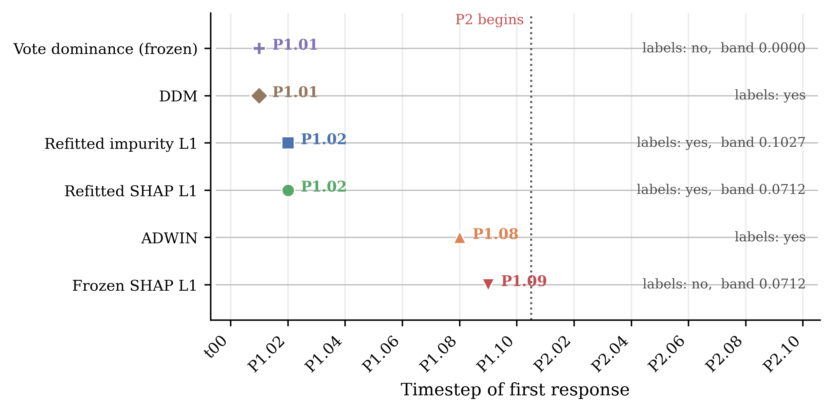
Figure 4.1 First responses across the harness timesteps
First response of every signal and detector on the Boolean harness across the 21 timesteps. Marker shape and colour identify the signal; the dotted line marks the start of phase P2, from which feature D is strictly necessary.
The sufficient-pair structure was enumerated exhaustively at every timestep, as Section 3.5.4 describes. The set of two-feature subsets sufficient to determine the label contracts at the first mutation step, and feature D becomes strictly necessary at the phase-two transition. This is the S4 mechanism observed against exact ground truth, and it is the only evidence reported for S4 anywhere in this dissertation; no sampled approximation was computed on the benchmark stream.

4.3 Rotating-hyperplane results
The benchmark arm comprises 200,000 instances in 200 windows of 1,000. Window 0 trains the deployed forest and is excluded from every signal and detector stream thereafter, leaving 199 post-deployment windows. The class balance is 100,065 to 99,935, and the deployed forest misclassifies 51,557 of the 199,000 post-deployment instances, an error rate of 0.259.
The contrast between refitted and frozen attribution that motivates the design is visible in the aggregate. Across the stream, the largest movement in any single feature's normalised importance is 0.417 under refitting and 0.035 under the frozen model. Refitting exposes movement in the relationship that the frozen model does not register.

4.3.1 Behaviour of the candidate signals
The null bands were calibrated on window 0 across 100 bootstrap replicates, with each reference measured on the same basis as the signal it governs. Table 4.2 reports them, including the superseded in-sample dominance reference, retained because the size of its error is what forced the correction of Section 3.7.2.
Table 4.2 Hyperplane null-band calibration
Calibration on the rotating hyperplane stream from 100 bootstrap replicates of window 0. The final row is diagnostic only and is not used for any result.
Signal | Measurement basis | Reference | Null band
Refitted SHAP L1 | in sample | in-sample profile | 0.1874
Frozen SHAP L1 | out of bag | out-of-bag profile | 0.2162
Mean vote dominance | out of bag | 0.7244 | 0.0189
Mean vote dominance (superseded) | in sample | 0.9372 | 0.0046

The in-sample and out-of-bag dominance references differ by roughly 0.21, more than eleven times the out-of-bag band. Measured against the in-sample reference, the deviations at the first three windows are 0.2158, 0.2094 and 0.2093, reproducing the offset itself rather than any movement in the data. Measured against the out-of-bag reference, the same three deviations are 0.0029, 0.0034 and 0.0036, comfortably inside a band of 0.0189.
Under the corrected calibration the three candidate signals behave differently. Refitted SHAP L1 crosses its band at window 1 and remains above it for the required three consecutive windows. Frozen SHAP L1 raises no sustained alarm, and its trajectory remains far below its band across the whole stream. Mean vote dominance, calibrated out of bag, likewise produces no sustained alarm under the three-window persistence rule. The trajectories, and the single sustained crossing, are shown in Figure 4.2.
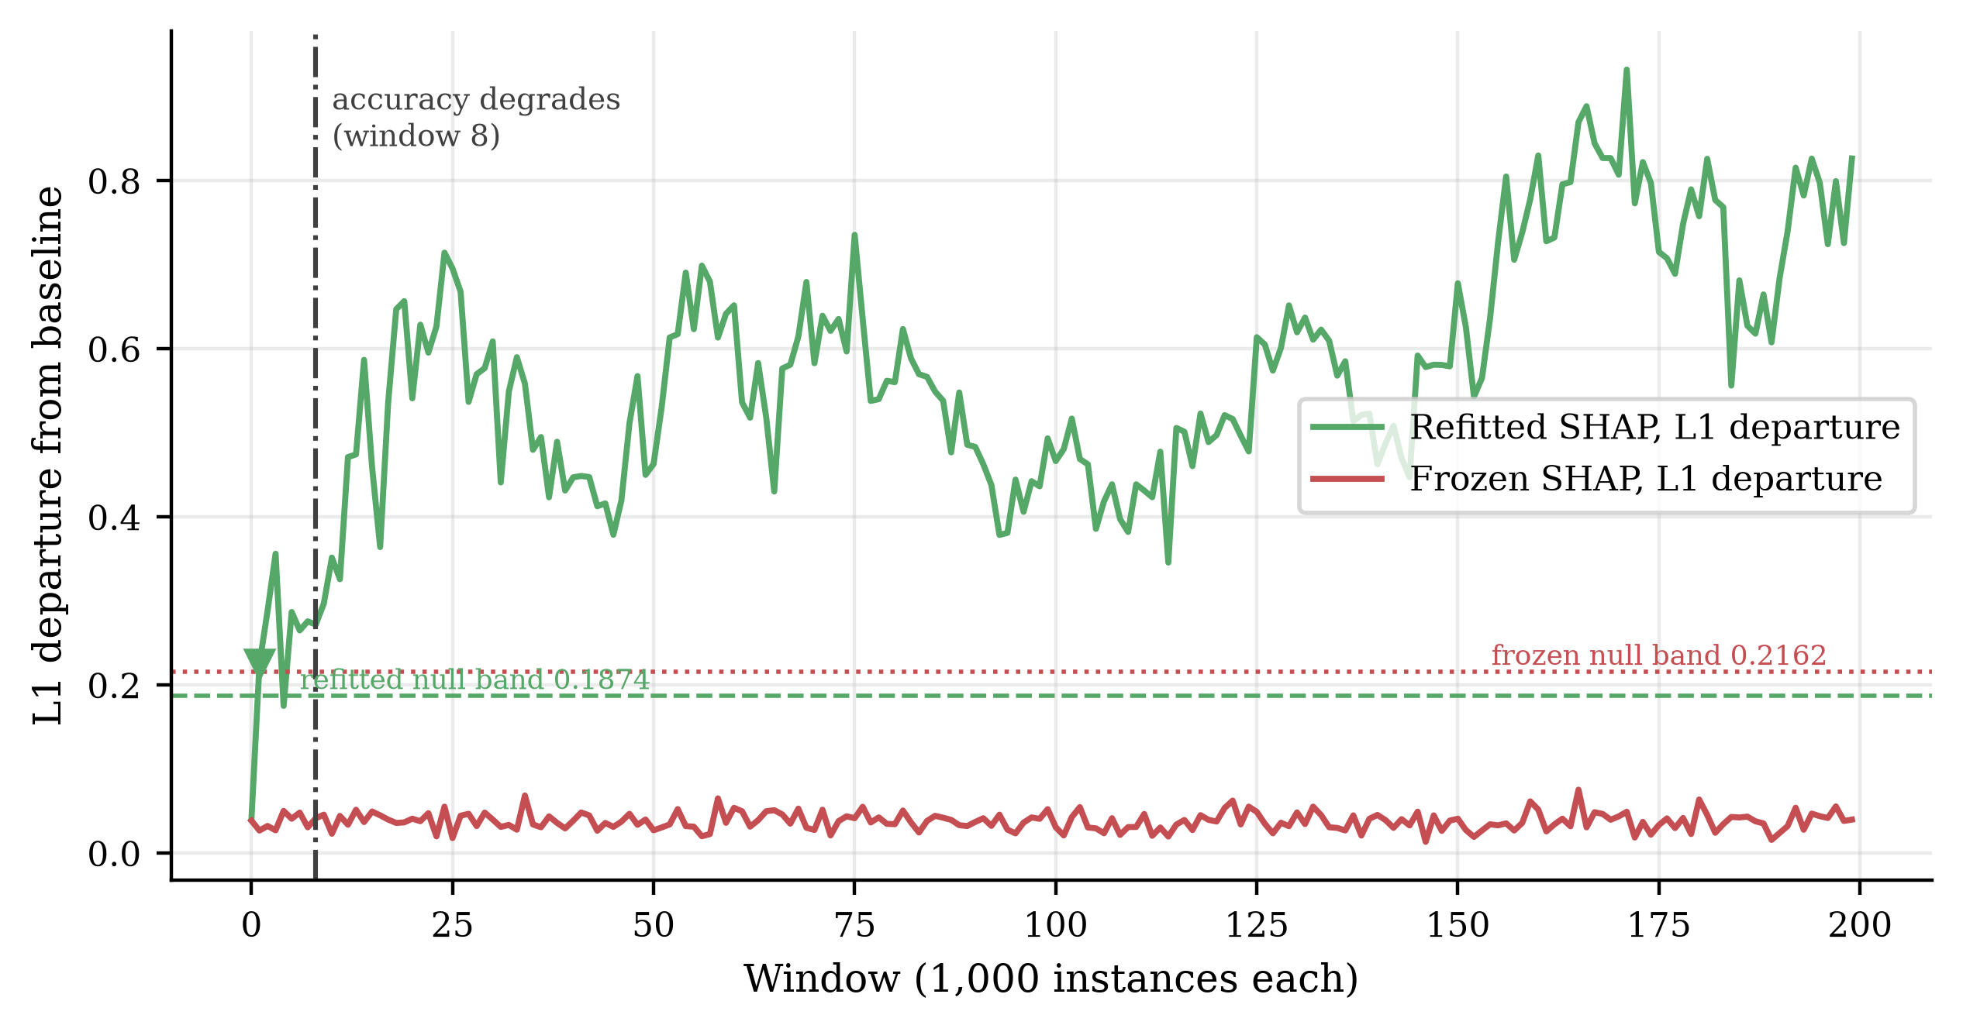
Figure 4.2 Refitted and frozen SHAP departures
L1 departure of the refitted and frozen SHAP importance profiles from the baseline profile across the rotating hyperplane stream, each against the null band on which it is tested. The marker shows the refitted signal's first sustained crossing; the frozen signal raises no sustained alarm. The vertical line marks the degradation window.
The two silent signals are the more consequential observation, and they are silent for the same reason. Both are computed from the frozen forest and the window inputs without labels, so the proposition of Section 3.2.1 applies to each directly. That the ensemble remains internally unanimous while its accuracy falls is the visible form the limitation takes, since dominance measures agreement rather than correctness and the two come apart once the boundary rotates away. Both results are predicted rather than detector failures, and they are why the two arms give different answers for S3.

4.3.2 Performance degradation and lead time
Lead time requires a point at which performance measurably degrades, and locating it requires a reference level. Following Section 3.8, the reference is the out-of-bag accuracy of the deployed forest on its own training window. Refitting the deployed configuration under the identical seed with out-of-bag scoring enabled left the fit unchanged: predictions matched across all 200,000 instances and every tree matched in both split feature and split threshold. The out-of-bag accuracy is 0.8330, giving a threshold of 0.8130, and the first window falling below it and staying below for three consecutive windows is window 8.
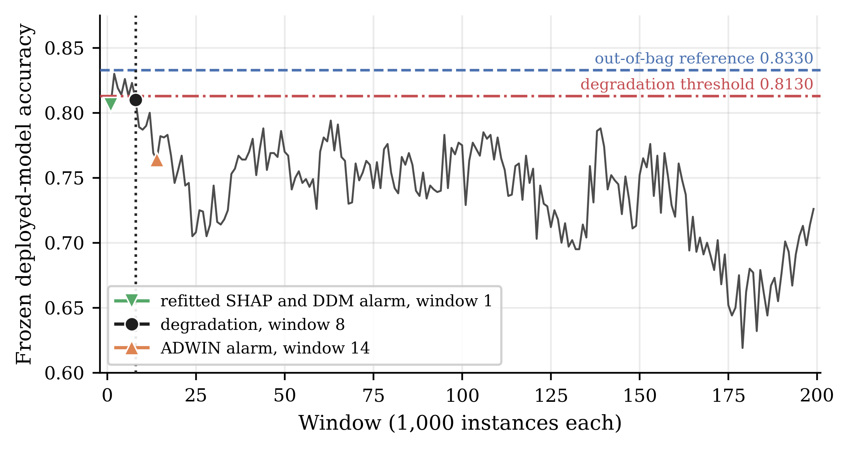
Figure 4.3 Frozen-model accuracy and detector alarms
Accuracy of the frozen deployed model across the 199 post-deployment windows, windows 1 to 199 of the 200-window stream. The dashed line is the out-of-bag reference of 0.8330, the dash-dotted line the degradation threshold of 0.8130; markers identify the first sustained crossing and the two baseline alarm windows.
The persistence requirement is doing work here. Window 1 records an accuracy of 0.8060, already below the threshold, but window 2 recovers to 0.8300 and the run is broken. Windows 8, 9 and 10 record 0.8100, 0.7890 and 0.7870, and the run holds. A rule without a persistence condition would have placed degradation at window 1 on a single dip.
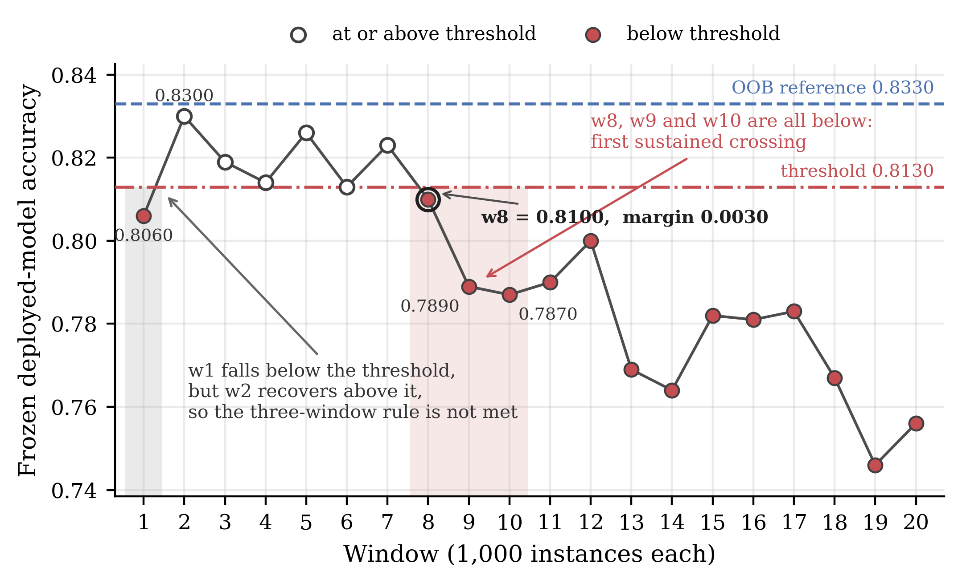
Figure 4.4 Three-window degradation persistence
The first twenty windows, showing how the three-window persistence rule locates the degradation point. Window 1 falls below the threshold but window 2 recovers; windows 8, 9 and 10 are the first three consecutive windows below it. The margin at window 8 is 0.0030.
The margin at the degradation window is narrow and should be stated plainly. Window 8's accuracy of 0.8100 lies 0.0030 below the threshold of 0.8130. A downward shift in the out-of-bag reference of approximately 0.003 would lift window 8 above the threshold, move the degradation point to window 9, and shift every numerical lead in Table 4.4 by one window. The degradation window is therefore reported to within about one window rather than exactly, and the comparisons that follow should be read at that resolution.
This sensitivity is one reason the out-of-bag reference was adopted in place of one estimated from an early span of observed windows. Table 4.3 records what the alternative produced: two of the four candidate spans are circular, in that the degradation point falls inside the span used to derive it, and the remaining two disagree with each other by nine windows.
Table 4.3 Degradation-reference sensitivity
Sensitivity of the degradation point to a post-hoc reference span, reported as a diagnostic. None of the first four rows is used for any result in this dissertation.
Candidate reference span | Reference accuracy | Degradation window | Outside its own span
Windows 1-5 | 0.8190 | 9 | yes
Windows 1-10 | 0.8117 | 9 | no
Windows 1-15 | 0.8015 | 18 | yes
Windows 1-20 | 0.7928 | 18 | no
Out-of-bag (adopted) | 0.8330 | 8 | not applicable

Table 4.4 is the canonical comparison for the rotating hyperplane stream. Lead time is the degradation window minus the alarm window, so a positive value denotes warning in advance of measurable degradation.
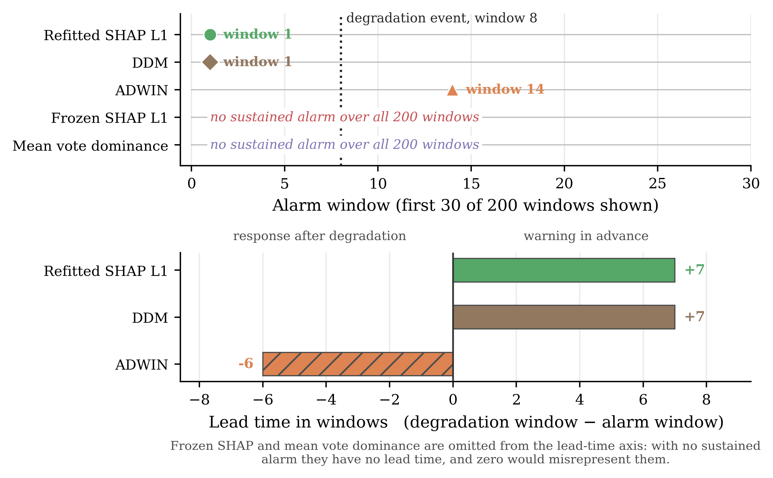
Figure 4.5 Benchmark alarm and lead-time comparison
The upper panel places each first alarm against the degradation event at window 8; the lower panel gives the resulting lead times. Signals raising no sustained alarm carry no lead-time bar.
Table 4.4 Benchmark alarms and lead times
Alarms and lead times on the rotating hyperplane stream, relative to degradation at window 8 against an out-of-bag reference of 0.8330. Single-run point estimates; see Section 4.3.2 on the 0.0030 margin.
Method | Labels required | Alarm window | Lead time (windows)
Refitted SHAP L1 | yes | 1 | +7
Frozen SHAP L1 | no | no alarm | not applicable
Mean vote dominance | no | no alarm | not applicable
DDM | yes | 1 | +7
ADWIN | yes | 14 | -6

4.3.3 Error-based baselines and negative controls
Both baseline detectors received the per-instance binary error stream of the frozen deployed model, in stream order, at their River defaults. DDM raised its first alarm at instance 1,748, in window 1, and two alarms in total. ADWIN raised its first alarm at instance 14,407, in window 14, and eight in total. On raw first-alarm timing, therefore, refitted SHAP L1 does not beat DDM: both respond at the earliest window the protocol can report. ADWIN responds six windows after degradation is already measurable.
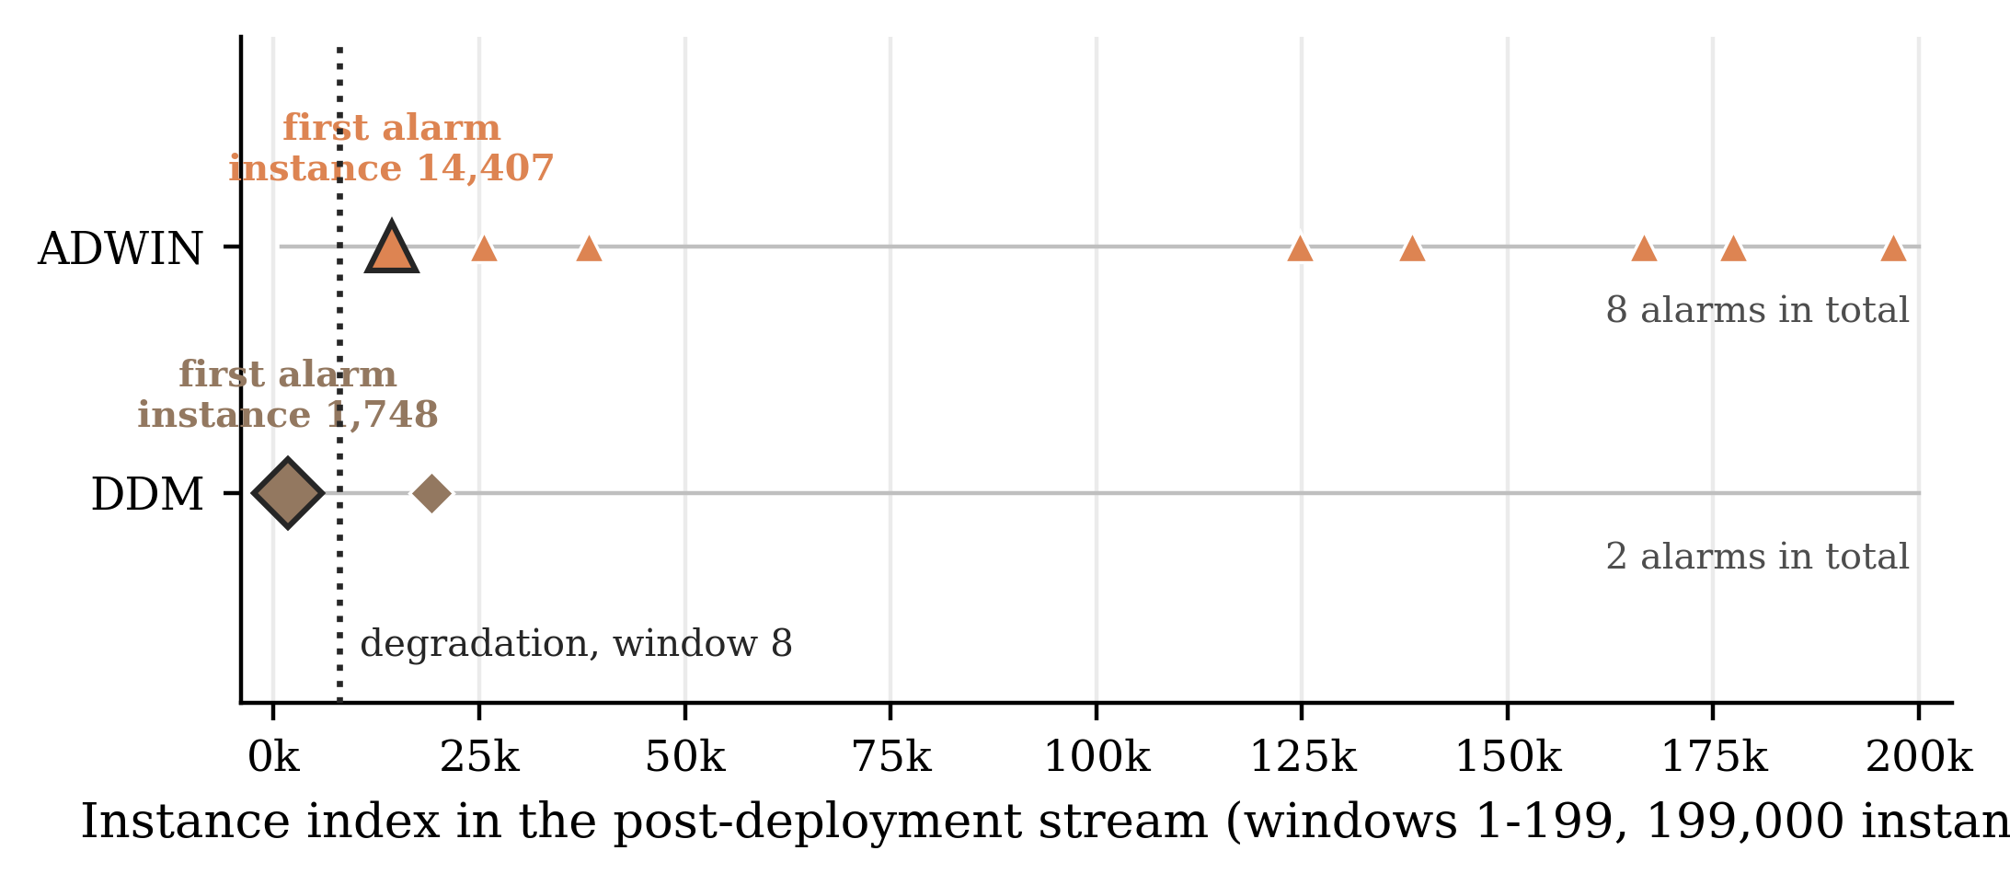
Figure 4.6 DDM and ADWIN alarm locations
Every alarm raised by ADWIN and DDM along the 199,000-instance post-deployment stream. Enlarged markers denote each detector's first alarm; the dotted line marks the degradation window.
The negative controls qualify these timings, and they qualify DDM's sharply. Under permutation of the frozen error stream, ADWIN raised no alarm in any of three replicates. DDM raised alarms in two of the three, at instance 2,173 in window 2 and at instance 1,157 in window 1, the latter earlier within the stream than its own chronological alarm at instance 1,748; the third was silent. DDM's early alarm is therefore initialisation-sensitive: on a stream with no temporal structure it fires about as early as on the real one, though not reproducibly.
Under joint permutation of the paired data, with full recalibration and refitting, refitted SHAP L1 alarmed at window 106 against window 1 chronologically, while the two silent signals remained silent on both. The separation is large and consistent with the chronological alarm depending on temporal ordering. It is not zero, and no claim is made that this signal produces no false alarms. This control is also weaker than its counterpart for the detectors: joint permutation does not hold the deployed model's error rate fixed, and its mean accuracy was 0.741 chronologically against 0.781 permuted.
Both controls are qualitative sensitivity analyses rather than formal false-positive experiments: three error-stream permutations for the baseline detectors and one joint permutation for the candidate signals. Neither constructs a reference distribution, and neither estimates a false-positive rate. Table 4.5 reports them together, and the two blocks should not be compared directly.
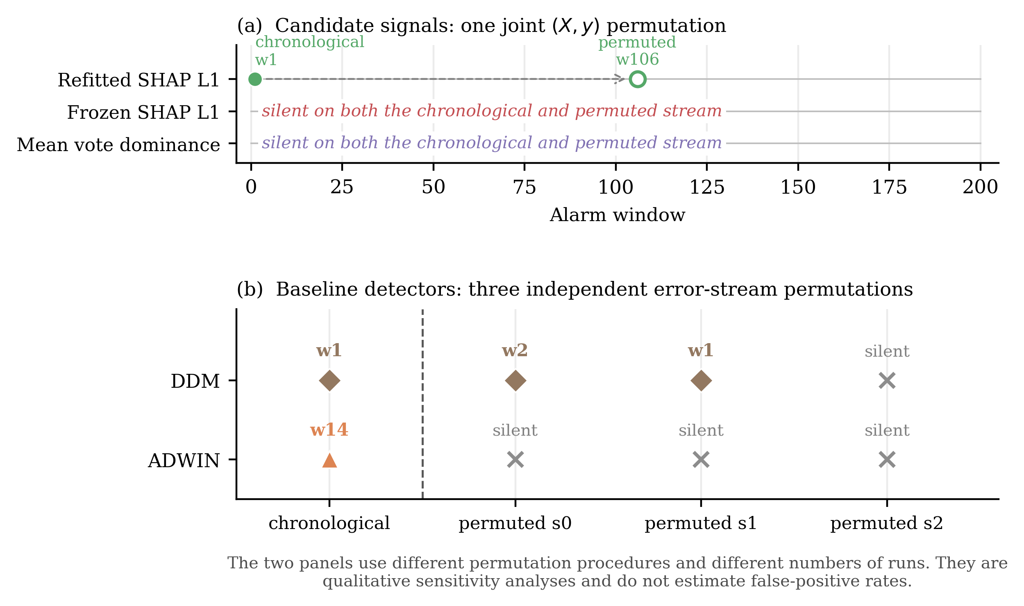
Figure 4.7 Chronological and negative-control timings
Panel (a) shows the single joint permutation applied to the candidate signals, panel (b) the three error-stream permutations applied to the baseline detectors. Negative controls are qualitative sensitivity analyses and do not estimate false-positive rates.
Table 4.5 Negative-control results
The two blocks use different procedures and are not directly comparable: three error-stream permutation replicates for DDM and ADWIN, one joint-permutation run for the candidate signals.
Method | Chronological | Permuted control result(s) | Control procedure
ADWIN | window 14 | silent, silent, silent | error-stream permutation
DDM | window 1 | window 2, window 1, silent | error-stream permutation
Refitted SHAP L1 | window 1 | window 106 | joint permutation
Frozen SHAP L1 | no alarm | no alarm | joint permutation
Mean vote dominance | no alarm | no alarm | joint permutation

4.4 Answers to the research questions
RQ1 asked whether variable-importance signals shift detectably when real concept drift occurs. The answer is affirmative under refitting and negative for frozen statistics. On the benchmark stream the refitted departure crossed its calibrated band and remained above it while the frozen equivalent raised no sustained alarm, with largest single-feature movements of 0.417 and 0.035 respectively; on the harness, refitting tracked feature D from 0.154 to 0.500 while frozen attribution fell to 0.025.
RQ2 asked whether such signals move earlier than performance degrades. Refitted SHAP L1 alarmed at window 1 and measurable degradation occurred at window 8, an observed lead of seven windows, subject to the 0.0030 margin and the single-run qualification stated above. The question does not arise for the other two signals, which produced no alarm to time.
RQ3 asked how the mechanisms compare with the baselines. Refitted SHAP L1 and DDM tied at window 1, so no claim of earlier detection is available; ADWIN alarmed at window 14, after degradation was measurable. Under their controls ADWIN was silent in all three permuted error streams, DDM alarmed in two of three and is therefore not clearly separated from its controls, and the refitted signal moved to window 106. Because the procedures differ, these outcomes order the methods qualitatively and estimate no rate. Frozen SHAP L1 and mean dominance raised no sustained alarm, both predicted by Section 3.2.1. S4 was evaluated only on the harness and enters neither the timing comparison nor the benchmark control.

4.5 Chapter summary
On the Boolean harness, refitted importance responded at the second mutation step, vote dominance at the first against an exactly zero null band, and frozen attribution moved opposite to the underlying change before crossing its band at P1.09. The set of sufficient feature pairs contracted at the first mutation step and feature D became strictly necessary at the phase-two transition.
On the rotating hyperplane stream, refitted SHAP L1 alarmed at window 1 against a null band of 0.1874, seven windows before accuracy degraded measurably at window 8 relative to an out-of-bag reference of 0.8330. Frozen SHAP L1 and out-of-bag calibrated mean vote dominance raised no sustained alarm at any window. DDM alarmed at window 1 and ADWIN at window 14. Under negative control, ADWIN was silent in all three error-stream permutations and DDM alarmed in two of three; under the single joint permutation, refitted SHAP L1 moved from window 1 to window 106.
Three cautions are carried into Chapter 5. The degradation window rests on a margin of 0.0030 and is established to within about one window; all timings are single-run point estimates without replication across streams; and the silence of the two frozen-model signals is a substantive result about what those signals can measure, not a shortfall in their implementation.

Chapter 5: Discussion

5.1 Overview
Chapter 4 reported what the two arms produced. This chapter interprets those results: why the signals behaved as they did, how the two arms fit together, what follows in answer to the research questions, and what follows for practice. No new results are introduced and Chapter 4's tables are not restated.
The principal finding is not that a SHAP-based signal detects drift early. It is that what a statistic is computed from determines whether concept drift is observable through it at all. A statistic computed from a frozen model and unlabelled inputs describes the deployed model under the input distribution; a model refitted on recent data exposes the reliance structure the current conditional relationship supports. Only the second responds to a change in P(y | X) when the input distribution holds still. The harness establishes that reliance structure can reorganise while achievable accuracy is untouched; the benchmark establishes what remains observable when P(X) is fixed by construction.

5.2 RQ1: when do variable-importance signals detect drift?
The evidence for RQ1 is consistent across both arms. Refitted attribution departed from its reference immediately and sustainedly on the benchmark while the frozen profile raised no sustained alarm, and on the harness refitted attribution tracked feature D's acquisition of necessity while frozen attribution moved in the opposite direction. The frozen signal did not merely fail to move; it moved the wrong way.
The operative distinction is not SHAP against some other importance measure. It is frozen explanation against refitted measurement. A frozen attribution is not wrong when it stays still: it faithfully describes the model it explains, which is precisely a model that has become unsuited to the current concept. The inversion on the harness is the sharpest form of the point: as D becomes indispensable, the frozen forest allocates progressively less attribution to it. The explanation remains accurate about the model and progressively less informative about the world (Rudin, 2019; Molnar, 2020).
This does not place the present work in opposition to the literature of Section 2.5. Demšar and Bosnić (2018) and Fumagalli et al. (2023) both operate on models being updated, a refitted rather than a frozen setting, so the present results are consistent with theirs. Lee et al. (2023) derive a label-free drift score from SHAP values against a reference set, closest to the frozen track examined here, and Section 3.2.1 delimits when such an approach can work. Pawlicki, Kozik and Choraś (2026) report that TreeSHAP distributions can remain stable under a drift that degrades performance, which is what the argument here predicts of a frozen explainer.
What this dissertation adds is the explicit treatment of the frozen-versus-refitted choice as a measurement decision that determines observability, tested on a benchmark where the generator holds P(X) stationary. The cost should not be understated: refitting requires labels for the window on which the model is fitted, so the refitted signal does not address the delayed-label problem that motivates much unsupervised drift detection (Sethi and Kantardzic, 2017). What it offers is earlier warning once labels sufficient for a local refit have arrived.

5.3 RQ2: does importance movement provide useful lead time?
Under the adopted degradation definition, the refitted SHAP signal provided a nominal seven-window lead: it alarmed at the first measurable window, and the frozen model's accuracy first fell below the out-of-bag reference by more than the stated margin, and stayed below for three consecutive windows, at window 8. At the window length used this corresponds to roughly seven thousand instances.
That figure carries qualifications which are not decorative. The accuracy at window 8 lies 0.0030 below the threshold, so a downward shift in the reference of about that size would move the degradation point to window 9 and every lead with it; the degradation timing is resolved to approximately one window rather than exactly. The measurement is also a single realisation of a single stream under one seed, with no replication across independently generated streams. The honest formulation is that a seven-window lead was observed under this degradation definition on this realisation.
The operational reading is more interesting than the number. A reliance signal can move before the deployed model has accumulated a persistent performance shortfall, because the two quantities measure different things: one asks what an adequate model would now rely upon, the other how often the deployed model is currently wrong. There is no reason for these to coincide, and on this stream they did not. Movement in a reliance signal is not by itself a retraining trigger; a defensible use is graduated, with signal movement marking a window for investigation and confirmed degradation justifying stronger intervention.
One design parameter deserves mention because it was fixed rather than explored. All benchmark results use windows of one thousand instances. Window length governs a trade-off between timing resolution and the stability of a window-level estimate: shorter windows locate events more precisely but make every profile noisier, which widens the null band and delays crossing. Nothing here establishes how the observed lead would behave at other window lengths.

5.4 RQ3: comparison with the error-based baselines
The comparison divides by method, because the four mechanisms differ in what they measure and in how they behaved under their negative controls.

5.4.1 Refitted SHAP and DDM
Refitted SHAP L1 and DDM both alarmed at window 1. The experiment therefore does not show the proposed signal detecting drift earlier than an established error-based detector; they tie at the earliest window the protocol can report, and window 1 is the floor of the measurable range rather than a discriminating result. The tie is moreover a tie at the adopted window resolution. DDM operates instance-wise and raised its alarm at instance 1,748, whereas the SHAP statistic becomes available only once a complete 1,000-instance window has accumulated and the window-level analysis has been performed. Neither ordering follows from this: the two are measured at different granularities, and the comparison is reported at the coarser of the two.
The two alarms differ under their negative controls. DDM alarmed in two of three permuted error streams, at windows 2 and 1, so its early chronological alarm is not clearly separated from its behaviour on streams with no temporal structure. Refitted SHAP L1 moved from window 1 to window 106 under the single joint permutation. The defensible conclusion is that the refitted alarm displayed stronger chronological-versus-permuted separation in the controls that were run. It does not follow that SHAP is more reliable than DDM, that DDM produces false alarms, or that either has a lower false-positive rate; none of those quantities was estimated, and the two controls use different procedures.

5.4.2 ADWIN
ADWIN alarmed at window 14, six windows after degradation was already measurable, and was silent in all three permuted error streams. In this experiment it is the most conservative detector and has the cleanest negative-control behaviour, at the price of responding only once deterioration has accumulated. That is a coherent trade-off rather than a defect. It is also a single observation on a single stream at library defaults, and no general ordering of the two detectors is inferred.

5.4.3 Vote dominance
The contrast in S3 between the two arms is what the framing of Section 3.2.1 predicts. On the harness, vote dominance responded at the first mutation step against a null band that is exactly zero, and did so without labels. On the benchmark it raised no sustained alarm once calibrated out of bag. Mean vote dominance is computed from the frozen forest and the window inputs alone, so it falls under the proposition directly. The harness differs precisely because its mutation moves the realised support, presenting the frozen forest with configurations it never saw.
This narrows the practical scope of the signal rather than eliminating it. Vote dominance remains a cheap, label-free diagnostic of change in the inputs relative to the deployed model. What it is not is a general detector of conditional drift, and the distinction matters operationally: a monitor silent under pure conditional drift will be silent exactly when the deployed model is quietly becoming wrong.

5.4.4 Reliance structure
S4 is discussed apart from the benchmark comparison because it was evaluated on one arm only. On the harness the set of sufficient feature pairs contracted from six to three at the first mutation step and feature D became strictly necessary at the phase-two transition, while the refitted forest classified the data perfectly at every timestep. That conjunction is the substantive point: the structure of adequate solutions reorganised while achievable accuracy did not move at all. A monitor watching accuracy would have seen nothing, and one watching a single fitted model would have seen only its arbitrary allocation among substitutable features.
The scope of that support is narrow. The structure was enumerated exhaustively because the harness is Boolean and its label a deterministic function of five binary features, which leaves only ten two-feature subsets to test at each timestep. No approximation of a Rashomon set was computed on the continuous benchmark stream, no Model Class Reliance interval was estimated anywhere in this dissertation, and S4 was never timed against measurable degradation. It is a validated proof of mechanism under exact ground truth, not a drift detector evaluated on benchmark data.

5.5 What the two arms establish together
The two arms invite reading as a validation exercise followed by a real experiment, which understates the design: they differ in the kind of drift they contain, and that difference is what makes the pair informative.
The harness supplies exact reliance ground truth, a perfect refitted predictor at every timestep, and a mutation that moves the realised input support; as Section 3.3.2 records, it is not pure real concept drift. Its value is that measurements can be checked against a known answer, and that holding refitted accuracy at 1.00 removes any possibility that a refitted importance signal is an accuracy proxy in disguise. The benchmark supplies the opposite configuration: P(X) fixed and the boundary rotating, giving conditional drift with no discrete onset and no stable period.
Five things follow from the pair that neither establishes alone. Reliance structure can reorganise while achievable accuracy is constant, so a change in what a model should rely upon is not reducible to a change in how well it performs. Refitting exposes that reorganisation, on both arms. Frozen model-internal statistics can be informative, and promptly so, when the inputs or their realised support change; but they cannot be expected to reveal conditional drift when the input distribution is stationary. Consequently, whether importance-based early warning is available at all depends on the measurement design as much as on the choice of importance statistic.

5.6 Contributions
The contributions are methodological rather than algorithmic, and are stated with the scope the evidence supports: the observability proposition of Section 3.2.1, covering frozen attribution and frozen vote dominance alike; the explicit separation of refitting as measurement from retraining as adaptation; the lead-time framing against a measurable, persistent degradation event rather than an assumed discrete onset; the use of an enumerable Boolean setting to verify sufficiency, relevance and necessity against ground truth; and the permutation negative control, applied to the proposed signals and the baselines alike.
None of these ingredients is claimed as individually unprecedented. Explanation-based drift detection, online importance monitoring, SHAP-based drift scores and Rashomon sets are all established, as Sections 2.4 to 2.6 set out. Taken together, and applied to a stream where the generator guarantees stationary P(X), they constitute this dissertation's methodological contribution.

5.7 Implications for model monitoring practice
For an organisation monitoring a deployed model, the results argue against replacing performance monitoring with an explanation-based monitor, and in favour of layering measurements that fail in different ways.
A first layer of cheap, label-free monitoring covers the input distribution and model-internal diagnostics such as ensemble disagreement. It runs continuously, costs little, and detects movement in the inputs or their realised support relative to the deployed model. The present results establish what it cannot do: under a stationary input distribution it will not systematically register a change in the conditional relationship, and its silence must not be read as evidence that the model remains valid.
A second layer is performance monitoring on labels as they arrive, using detectors of the DDM and ADWIN family. This measures harm directly, but the present results illustrate its timing characteristics: one detector was fast but poorly separated from its permuted controls, the other clean under those controls but responsive only after degradation was measurable.
A third layer, the one this dissertation contributes to, is periodic refitted reliance monitoring: when labels for a recent window become available, a window-local shadow model is fitted and its reliance profile compared against the reference, and sustained movement marks a candidate for investigation. The shadow model exists to measure, not to be promoted; replacing the production model automatically on the strength of a reliance shift would conflate a diagnostic with a remediation decision.
The value of the third layer lies less in raw earliness than in what it reports: a reliance profile identifies which features moved and distinguishes input shift from reliance shift, which bear on different remedies. Against this sit real costs. Repeated fitting and attribution are dearer than tracking an error rate; current labels are required, so the layer inherits the delayed-label constraint rather than solving it; and thresholds are empirical and application-specific. Acting on a single alarm risks model churn, so in regulated settings the signal belongs in a governance process with human review.

5.8 Limitations and what they restrict
Section 3.12 states the design limitations in full. What follows is what each restricts in the interpretation above.
Replication limits claims about timing. Both arms rest on a single realisation of a single stream at a single window length, so no confidence statement attaches to the seven-window lead, and the one-window sensitivity of the degradation point compounds this: differences of one or two windows between methods carry no evidential weight.
Data limits external validity. Both sources are synthetic, which is what makes ground truth available and simultaneously what prevents any claim about operational data. All signals are computed over random forests, so the results do not transfer to model families without an ensemble vote structure.
Calibration limits inferential strength. The null bands describe observed variation rather than testing a hypothesis, no family-wise control is applied, and the permutation controls use different procedures for the two families. They support an ordering, not a rate.
Scope limits the headline motivation and the S4 claim. The refitted signal requires labels, so what is demonstrated is earlier warning given labels, not warning without them. S4 was demonstrated on the harness alone, with no continuous-stream approximation and no Model Class Reliance estimation. And no relevance-preserving contrast stream was implemented, so the claim that the importance signals correctly stay silent when feature relevance is preserved remains untested.

5.9 Chapter summary
Refitted reliance measurement was the only mechanism in the benchmark arm that produced the intended early warning, alarming at the first measurable window against degradation at window 8. Frozen SHAP and mean vote dominance raised no sustained alarm there, as Section 3.2.1 predicts of any label-free statistic of a frozen model under stationary P(X). DDM matched the refitted signal's timing exactly, though its alarm showed less chronological-versus-permuted separation; ADWIN was slower but clean under the same controls. The sufficient-subset analysis validated the rationale but remains a harness-only proof of mechanism.
The practical implication is layered monitoring rather than substitution: cheap label-free diagnostics for input and support change, performance monitoring for harm, and periodic refitted reliance measurement as a diagnostic that reports which features have moved and when.

Chapter 6: Conclusions and Future Research
This chapter states the conclusions against the three research questions, identifies the contributions, sets out the implications for model monitoring, and identifies the extensions the design's limitations make most urgent. Chapter 5 supplies the interpretation; this chapter synthesises it.

6.1 Conclusions against the research questions
RQ1 asked whether variable-importance signals shift detectably when real concept drift occurs. They did, but only under refitting. On the benchmark the refitted profile departed from its reference immediately and sustainedly while the frozen profile raised no sustained alarm; on the harness, refitted attribution tracked feature D's acquisition of necessity while frozen attribution moved in the opposite direction. The implication concerns measurement design rather than statistic selection: a label-free statistic computed from a frozen model reads the input distribution, so under stationary P(X) it cannot systematically register movement in P(Y | X).
RQ2 asked whether such signals move earlier than predictive performance degrades. On the benchmark the refitted signal alarmed at window 1, and the deployed model's accuracy first fell more than 0.02 below the out-of-bag reference of 0.8330 and stayed below for three consecutive windows at window 8, an observed lead of seven windows. Two qualifications are not detachable from that figure: the accuracy at window 8 lies only 0.0030 below the adopted threshold, so the degradation point is resolved to approximately one window; and the measurement is a single-run point estimate on one stream realisation. The seven-window lead is an observed result on the evaluated stream, not a property of the method.
RQ3 asked how the mechanisms compare with the error-based baselines. Refitted attribution and DDM tied at window 1, the earliest measurable window, so the experiment supports no claim of earlier detection; as Section 5.4.1 notes, that tie is at the adopted window resolution. ADWIN alarmed at window 14. Under their controls ADWIN was silent in all three permuted error streams, DDM alarmed in two of three and is therefore not clearly separated from its controls, and the refitted signal moved to window 106; because the procedures differ these outcomes order the methods qualitatively and estimate no rate. Vote dominance was informative only where the realised input support moves, and the sufficient-subset analysis rests on harness evidence alone.

6.2 Contributions
The contributions are methodological. The dissertation formalises an observability limitation: any window statistic computed from a frozen model and unlabelled inputs is a deterministic function of the empirical input distribution, and cannot systematically respond to conditional drift when that distribution is stationary. It makes the frozen-versus-refitted choice explicit as a measurement decision, separating refitting used to observe a stream from retraining used to adapt a deployed model. It evaluates timing against a measurable, persistent degradation event. It validates sufficient-subset measurement against exact ground truth in an enumerable Boolean setting. And it applies a permutation negative control to the proposed signals and the baselines alike. None of these ingredients is individually new; taken together they constitute the dissertation's methodological contribution.

6.3 Implications for model monitoring
For an organisation monitoring a deployed model, the results argue for layering measurements that fail in different ways rather than substituting one for another: cheap label-free diagnostics of the input distribution and model-internal statistics, whose silence is not evidence that the model remains valid; error monitoring as labels arrive, measuring harm directly; and a window-local shadow model fitted when labels permit, whose reliance profile is compared against the reference.
A reliance alarm should trigger investigation, not automatic replacement: promoting the shadow model on the strength of a reliance shift would conflate a diagnostic with a remediation decision. The practical value of the third layer lies in what it reports rather than in earliness alone, since it identifies which features moved and distinguishes input shift from reliance shift. Against this sit the costs: refitting and attribution are dearer than tracking an error rate, current labels are required, thresholds are empirical, and acting on single alarms risks model churn. Two synthetic sources do not establish production readiness, and none is claimed.

6.4 Limitations
Section 3.12 states the design limitations in full and Section 5.8 what each restricts. Four bear directly on the conclusions above: both data sources are synthetic and one learner family is used, restricting external validity; the benchmark rests on a single stream realisation at a single window length, which is why no confidence statement attaches to the seven-window lead; calibration is empirical, with no multiple-testing control; and the successful signal requires labels, which qualifies the label-free motivation much of the literature begins from.

6.5 Future research
The most valuable next step is replication. Generating independent streams under multiple seeds and reporting timing as a distribution rather than a point estimate would establish whether the observed lead is stable. A window-size sensitivity analysis would separate the timing result from the resolution at which it was measured. A relevance-preserving contrast stream, in which the boundary moves while the set of relevant features does not, would test whether the importance signals correctly stay silent when there is nothing to detect.
Three extensions would broaden the evidence base. Real operational data containing mixed and unscheduled drift would test external validity directly. Additional learner families would establish whether the observability argument, which is general, is matched by comparable behaviour in models without an ensemble vote structure. And sampled Rashomon sets on continuous data, followed by formal Model Class Reliance estimation, would extend the reliance arm beyond the enumerable case.
Two further directions concern rigour and deployment. Formal calibration with multiple-testing control would replace the empirical null band with a procedure carrying stated error rates. And the operational questions remain open: how the approach behaves when labels arrive late, what it costs at production scale, and whether reliance alarms actually improve retraining decisions relative to error monitoring alone. That last question is the one an organisation would ask first, and the present design does not answer it.

6.6 Concluding remark
Whether concept drift is observable through variable importance depends not on which importance statistic is chosen but on what model and what data the statistic is computed from. A frozen explanation describes the deployed model under the inputs it receives, and remains faithful to that model as the model becomes unsuited to its environment. Exposing the change requires refitting, and refitting requires labels. The early-warning capability demonstrated here is therefore real but conditional, and is best understood as one measurement in a layered monitoring design rather than as a replacement for monitoring performance itself.

References
Baena-García, M., del Campo-Ávila, J., Fidalgo, R., Bifet, A., Gavaldà, R. and Morales-Bueno, R. (2006) 'Early drift detection method', Fourth International Workshop on Knowledge Discovery from Data Streams, 6, pp. 77–86.
Bayram, F., Ahmed, B.S. and Kassler, A. (2022) 'From concept drift to model degradation: an overview on performance-aware drift detectors', Knowledge-Based Systems, 245, 108632. doi: 10.1016/j.knosys.2022.108632.
Bifet, A. and Gavaldà, R. (2007) 'Learning from time-changing data with adaptive windowing', Proceedings of the 2007 SIAM International Conference on Data Mining, pp. 443–448. doi: 10.1137/1.9781611972771.42.
Bifet, A., Holmes, G., Kirkby, R. and Pfahringer, B. (2010) 'MOA: massive online analysis', Journal of Machine Learning Research, 11, pp. 1601–1604. Available at: https://jmlr.org/papers/v11/bifet10a.html.
Breiman, L. (2001a) 'Random forests', Machine Learning, 45(1), pp. 5–32. doi: 10.1023/A:1010933404324.
Breiman, L. (2001b) 'Statistical modeling: the two cultures', Statistical Science, 16(3), pp. 199–231. doi: 10.1214/ss/1009213726.
Covert, I., Lundberg, S.M. and Lee, S.-I. (2020) 'Understanding global feature contributions with additive importance measures', Advances in Neural Information Processing Systems, 33.
Demšar, J. and Bosnić, Z. (2018) 'Detecting concept drift in data streams using model explanation', Expert Systems with Applications, 92, pp. 546–559. doi: 10.1016/j.eswa.2017.10.003.
Ditzler, G., Roveri, M., Alippi, C. and Polikar, R. (2015) 'Learning in nonstationary environments: a survey', IEEE Computational Intelligence Magazine, 10(4), pp. 12–25. doi: 10.1109/MCI.2015.2471196.
Dong, J. and Rudin, C. (2020) ’Exploring the cloud of variable importance for the set of all good models’, Nature Machine Intelligence, 2(12), pp. 810–824. doi: 10.1038/s42256-020-00264-0.
dos Reis, D.M., Flach, P., Matwin, S. and Batista, G. (2016) 'Fast unsupervised online drift detection using incremental Kolmogorov–Smirnov test', Proceedings of the 22nd ACM SIGKDD International Conference on Knowledge Discovery and Data Mining, pp. 1545–1554. doi: 10.1145/2939672.2939836.
Fisher, A., Rudin, C. and Dominici, F. (2019) 'All models are wrong, but many are useful: learning a variable's importance by studying an entire class of prediction models simultaneously', Journal of Machine Learning Research, 20(177), pp. 1–81. Available at: https://jmlr.org/papers/v20/18-760.html.
Frías-Blanco, I., del Campo-Ávila, J., Ramos-Jiménez, G., Morales-Bueno, R., Ortiz-Díaz, A. and Caballero-Mota, Y. (2015) 'Online and non-parametric drift detection methods based on Hoeffding's bounds', IEEE Transactions on Knowledge and Data Engineering, 27(3), pp. 810–823. doi: 10.1109/TKDE.2014.2345382.
Fumagalli, F., Muschalik, M., Hüllermeier, E. and Hammer, B. (2023) ’Incremental permutation feature importance (iPFI): towards online explanations on data streams’, Machine Learning, 112(12), pp. 4863–4903. doi: 10.1007/s10994-023-06385-y.
Gama, J., Medas, P., Castillo, G. and Rodrigues, P. (2004) 'Learning with drift detection', Advances in Artificial Intelligence – SBIA 2004, Lecture Notes in Computer Science, 3171, pp. 286–295. doi: 10.1007/978-3-540-28645-5_29.
Gama, J., Sebastião, R. and Rodrigues, P.P. (2013) 'On evaluating stream learning algorithms', Machine Learning, 90(3), pp. 317–346. doi: 10.1007/s10994-012-5320-9.
Gama, J., Žliobaitė, I., Bifet, A., Pechenizkiy, M. and Bouchachia, A. (2014) 'A survey on concept drift adaptation', ACM Computing Surveys, 46(4), article 44, pp. 1–37. doi: 10.1145/2523813.
Gözüaçık, Ö., Büyükçakır, A., Bonab, H. and Can, F. (2019) 'Unsupervised concept drift detection with a discriminative classifier', Proceedings of the 28th ACM International Conference on Information and Knowledge Management. doi: 10.1145/3357384.3358144.
Haug, J., Braun, A., Zürn, S. and Kasneci, G. (2022) 'Change detection for local explainability in evolving data streams', Proceedings of the 31st ACM International Conference on Information and Knowledge Management. doi: 10.1145/3511808.3557257.
Hulten, G., Spencer, L. and Domingos, P. (2001) 'Mining time-changing data streams', Proceedings of the 7th ACM SIGKDD International Conference on Knowledge Discovery and Data Mining, pp. 97–106. doi: 10.1145/502512.502529.
Lee, Y., Lee, Y., Lee, E. and Lee, T. (2023) ’Explainable artificial intelligence-based model drift detection applicable to unsupervised environments’, Computers, Materials & Continua, 76(2), pp. 1701–1719. doi: 10.32604/cmc.2023.040235.
Losing, V., Hammer, B. and Wersing, H. (2016) 'KNN classifier with self adjusting memory for heterogeneous concept drift', Proceedings of the 16th IEEE International Conference on Data Mining, pp. 291–300. doi: 10.1109/ICDM.2016.0040.
Lu, J., Liu, A., Dong, F., Gu, F., Gama, J. and Zhang, G. (2019) 'Learning under concept drift: a review', IEEE Transactions on Knowledge and Data Engineering, 31(12), pp. 2346–2363. doi: 10.1109/TKDE.2018.2876857.
Lundberg, S.M. and Lee, S.-I. (2017) 'A unified approach to interpreting model predictions', Advances in Neural Information Processing Systems, 30, pp. 4765–4774.
Lundberg, S.M., Erion, G., Chen, H., DeGrave, A., Prutkin, J.M., Nair, B., Katz, R., Himmelfarb, J., Bansal, N. and Lee, S.-I. (2020) 'From local explanations to global understanding with explainable AI for trees', Nature Machine Intelligence, 2(1), pp. 56–67. doi: 10.1038/s42256-019-0138-9.
Molnar, C. (2020) Interpretable machine learning: a guide for making black box models explainable. Lulu.com. Available at: https://christophm.github.io/interpretable-ml-book/.
Montiel, J., Halford, M., Mastelini, S.M., Bolmier, G., Sourty, R., Vaysse, R., Zouitine, A., Gomes, H.M., Read, J., Abdessalem, T. and Bifet, A. (2021) 'River: machine learning for streaming data in Python', Journal of Machine Learning Research, 22(110), pp. 1–8. Available at: https://jmlr.org/papers/v22/20-1380.html.
Muschalik, M., Fumagalli, F., Hammer, B. and Hüllermeier, E. (2023) 'iSAGE: an incremental version of SAGE for online explanation on data streams', Machine Learning and Knowledge Discovery in Databases: Research Track (ECML PKDD 2023), Lecture Notes in Computer Science. Cham: Springer. doi: 10.1007/978-3-031-43418-1_26.
Nishida, K. and Yamauchi, K. (2007) 'Detecting concept drift using statistical testing', Discovery Science, Lecture Notes in Computer Science, 4755, pp. 264–269. doi: 10.1007/978-3-540-75488-6_27.
Page, E.S. (1954) 'Continuous inspection schemes', Biometrika, 41(1/2), pp. 100–115. doi: 10.1093/biomet/41.1-2.100.
Pawlicki, M., Kozik, R. and Choraś, M. (2026) ’Can SHAP-based explanations differentiate between concept drift and scale drift in computer networks data?’, in Koprinska, I., Mendes-Moreira, J. and Branco, P. (eds) Machine Learning and Principles and Practice of Knowledge Discovery in Databases (ECML PKDD 2025), Communications in Computer and Information Science, vol. 2842. Cham: Springer, pp. 129–139. doi: 10.1007/978-3-032-19105-2_9.
Pedregosa, F., Varoquaux, G., Gramfort, A., Michel, V., Thirion, B., Grisel, O., Blondel, M., Prettenhofer, P., Weiss, R., Dubourg, V., Vanderplas, J., Passos, A., Cournapeau, D., Brucher, M., Perrot, M. and Duchesnay, É. (2011) ’Scikit-learn: machine learning in Python’, Journal of Machine Learning Research, 12, pp. 2825–2830.
Rudin, C. (2019) 'Stop explaining black box machine learning models for high stakes decisions and use interpretable models instead', Nature Machine Intelligence, 1(5), pp. 206–215. doi: 10.1038/s42256-019-0048-x.
Saunders, M.N.K., Lewis, P. and Thornhill, A. (2019) Research Methods for Business Students. 8th edn. Harlow: Pearson Education.
Semenova, L., Rudin, C. and Parr, R. (2022) 'On the existence of simpler machine learning models', Proceedings of the 2022 ACM Conference on Fairness, Accountability, and Transparency, pp. 1827–1858. doi: 10.1145/3531146.3533232.
Sethi, T.S. and Kantardzic, M. (2017) 'On the reliable detection of concept drift from streaming unlabeled data', Expert Systems with Applications, 82, pp. 77–99. doi: 10.1016/j.eswa.2017.04.008.
Street, W.N. and Kim, Y. (2001) 'A streaming ensemble algorithm (SEA) for large-scale classification', Proceedings of the 7th ACM SIGKDD International Conference on Knowledge Discovery and Data Mining, pp. 377–382. doi: 10.1145/502512.502568.
Strobl, C., Boulesteix, A.-L., Zeileis, A. and Hothorn, T. (2007) 'Bias in random forest variable importance measures: illustrations, sources and a solution', BMC Bioinformatics, 8, article 25. doi: 10.1186/1471-2105-8-25.
Webb, G.I., Hyde, R., Cao, H., Nguyen, H.L. and Petitjean, F. (2016) 'Characterizing concept drift', Data Mining and Knowledge Discovery, 30(4), pp. 964–994. doi: 10.1007/s10618-015-0448-4.
Widmer, G. and Kubat, M. (1996) 'Learning in the presence of concept drift and hidden contexts', Machine Learning, 23(1), pp. 69–101. doi: 10.1007/BF00116900.
Žliobaitė, I., Pechenizkiy, M. and Gama, J. (2016) 'An overview of concept drift applications', in Japkowicz, N. and Stefanowski, J. (eds) Big Data Analysis: New Algorithms for a New Society. Studies in Big Data, vol. 16. Cham: Springer, pp. 91–114. doi: 10.1007/978-3-319-26989-4_4.

Appendix A Reproducibility and implementation configuration
This appendix records the environment, seeds and parameters under which every result reported in Chapters 3 and 4 was produced. The values are read from the executed notebooks and the virtual environment in which they were run; nothing here is reconstructed from memory. Appendices are excluded from the dissertation word count.

A.1 Software environment
All experiments were executed in a single isolated virtual environment under Python 3.12.12. The package versions were: scikit-learn 1.9.0; NumPy 2.5.2; pandas 3.0.5; SHAP 0.52.0; River 0.25.0; matplotlib 3.11.1. Python 3.14 was avoided because current SHAP and River releases are not compatible with it.

A.2 Base learner configuration
Rotating hyperplane benchmark: RandomForestClassifier with n_estimators = 100 and all remaining hyperparameters at scikit-learn defaults, fitted once on window 0 under a fixed random_state and thereafter frozen. The out-of-bag reference was obtained by refitting the identical configuration and seed with oob_score enabled; predictions across all 200,000 instances and every tree's split feature and split threshold were verified unchanged, so the deployed model itself was not altered.
Boolean validation harness: RandomForestClassifier with n_estimators = 300, max_features = 'sqrt' and bootstrap = True. The larger ensemble is used because vote dominance is quantised in units of one over the number of trees, and the harness contains duplicated and complementary columns whose tie-breaking behaviour is the object of interest.

A.3 Windowing, attribution and calibration
Benchmark window size 1,000 instances, giving 200 windows over 200,000 instances; window 0 trains the deployed forest and is excluded from every candidate signal and from the detector error stream, leaving 199 post-deployment windows. On the harness the window is the snapshot, 100 rows, across 21 snapshots. Attributions use the exact TreeSHAP algorithm: on the benchmark a random subsample of 200 instances per window; on the harness all 100 rows. Null bands on the benchmark are calibrated from 100 bootstrap replicates of window 0, each resampled with replacement and refitted under a new seed; on the harness, eight forests are refitted per timestep and the baseline refits form the band. The degradation rule is an accuracy fall of more than 0.02 below the out-of-bag reference, sustained for three consecutive windows.

A.4 Baseline detectors
DDM and ADWIN are used as implemented in River 0.25.0 at the library default parameters, unchanged throughout. Each receives the per-instance binary error stream of the frozen deployed model in stream order. No detector parameter was altered after any result had been observed.

A.5 Random seeds and permutation procedure
The Boolean harness generator and its mutation schedule use seed 42. The benchmark stream is a fixed published file and is not generated, so no stream seed applies; the forest initialisation and the per-window attribution subsample are drawn under fixed seeds. The negative controls comprise three error-stream permutations for the baseline detectors, under seeds 0, 1 and 2, in which the already-computed binary error stream is permuted and nothing is refitted; and one joint permutation of the paired data for the candidate signals, under seed 0, after which the pipeline is recalibrated and rerun in full.

A.6 Execution and verification
Both notebooks were restarted and executed from top to bottom in a single pass, with sequential execution counts and no errors, before any figure or table in Chapter 4 was taken from them. Each notebook contains an explicit verification cell asserting the canonical values reported in this dissertation, including the out-of-bag reference of 0.8330, the degradation threshold of 0.8130, degradation at window 8, the alarm windows of every signal and detector, the first alarm instances of DDM and ADWIN, the null bands, and the permutation-control outcomes. Execution halts if any of these assertions fails.

Appendix B Boolean validation harness: construction and enumeration
This appendix specifies the harness precisely enough for the results of Sections 3.3 and 4.2 to be regenerated. The full implementation is contained in the accompanying notebook.

B.1 Construction
Two latent binary variables u and v are drawn. Five features are observed: A = u; B = u, a duplicate of A; C = v; D = v, a duplicate of C; and E = 1 - v, the complement of v. The label is Y = u XOR v, and is therefore recoverable exactly as A XOR C. One timestep is all four combinations of (u, v) repeated 25 times, giving 100 rows with an exactly balanced label distribution. Every feature has a substitute, so at baseline six feature pairs determine the label exactly and no single feature is irreplaceable.

B.2 Mutation schedule
Drift is introduced by cumulative cell-level mutation of the feature columns on a without-replacement schedule. Each phase partitions the 100 row indices into ten disjoint groups of ten, so across a phase's ten steps every row is mutated exactly once and never twice. Phase P1 exchanges the values of A and D on the scheduled rows, a two-way operation. Phase P2 copies the value of E over B on the scheduled rows, a one-way overwrite. A third phase exchanging C and E is implemented but disabled by default. With the baseline block this yields 21 snapshots and 2,100 instances. The label column is never modified, so the drift is mutation of the features rather than injection of label noise. Because an exchange between columns already holding the same value has no effect, and the columns involved agree on about half the rows at baseline, the nominal mutation rate of 10 per cent per step corresponds to an effective rate of approximately 5 per cent.

B.3 Exhaustive enumeration of sufficient pairs and necessity
At each snapshot the structure is computed, not asserted, by exhaustive enumeration over all ten two-feature subsets. A pair S is recorded as sufficient when no two rows sharing the same values on S disagree on the label. A feature f is recorded as relevant when it appears in at least one sufficient pair, and as strictly necessary when the remaining features taken together no longer determine the label. Singleton sufficiency is checked separately, and the full feature set is checked once per snapshot to confirm a perfect predictor still exists. No larger subset is enumerated, and no model is enumerated under a loss tolerance. The procedure is:
for each snapshot t:
for each two-feature subset S of {A, B, C, D, E}: (all 10)
sufficient[S] = (no two rows equal on S disagree on Y)
pairs[t] = {S : sufficient[S]}
relevant[t] = {f : f appears in some sufficient pair S}
necessary[t] = {f : not determines(all features except f)}
singleton[t] = {f : sufficient({f})} (checked separately)
solvable[t] = determines({A, B, C, D, E}) (a perfect predictor still exists)
This enumeration is deterministic and involves no model fitting, no attribution and no sampling, so it reproduces exactly. It is the sole evidence reported for signal S4, and no model is enumerated under a loss tolerance at any point: no Model Class Reliance interval is estimated anywhere in this dissertation.

B.4 Verification of the dominance reference
The realised support at the baseline snapshot consists of four distinct feature vectors, each appearing 25 times. The frozen forest votes unanimously and correctly on all four, so mean vote dominance is exactly 1.000 on any sample drawn from the baseline concept and the in-sample optimism gap is exactly zero. This was verified both by enumerating the complete support and on a fresh same-concept window of 100 instances, which returned accuracy 1.000 with no row below unanimity.

